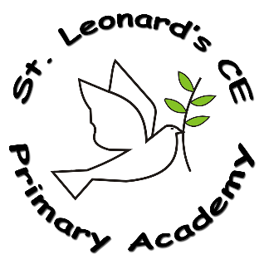

**Intent:**

**What do we want children to learn?**

At St Leonard’s we aim for our children to:

* Ensure every child has the opportunity throughout Key Stage 2, to study a foreign language and develop their interest in the culture of other nations
* Ensure pupils’ learning is enriched in a broad curriculum to which languages contribute
* Ensure pupils have access to high quality teaching and learning opportunities, through the use of EuroStars

**What French looks like at ST Leonard’s CE Primary Academy…**

We ensure pupils have access to high quality teaching and learning opportunities. Children have weekly French lessons throughout Key Stage 2, using Eurostars scheme of work as a framework. In Lower KS2, children acquire basic skills and an understanding of French, with emphasis placed on developing Speaking and Listening skills. These will be embedded and further developed in Upper KS2, alongside Reading and Writing, gradually progressing onto more complex language concepts and greater learner autonomy.

**French in a Nutshell**



**St Leonard’s CE Primary Academy**

**Impact:**

**On leaving ST Leonard’s CE Primary Academy children will:**

Children will have developed a natural curiosity and confidence to explore other countries, cultures and languages, accepting that, in a multi-lingual society, it is a valuable skill to be able to communicate effectively with others.

**Implementation:**

**How do we do it at ST Leonard’s CE Primary Academy?**

In line with the National Curriculum for MFL, pupils at St Leonard’s Primary Academy are taught to**:**

1. listen attentively to spoken language and show understanding by joining in and responding
2. explore the patterns and sounds of language through songs and rhymes and link the spelling, sound and meaning of words
3. engage in conversations; ask and answer questions; express opinions and respond to those of others; seek clarification and help
4. speak in sentences, using familiar vocabulary, phrases and basic language structures
5. develop accurate pronunciation and intonation so that others understand when they are reading aloud or using familiar words and phrases
6. present ideas and information orally to a range of audiences
7. read carefully and show understanding of words, phrases and simple writing
8. appreciate stories, songs, poems and rhymes in the language
9. broaden their vocabulary and develop their ability to understand new words that are introduced into familiar written material, including through using a dictionary
10. write phrases from memory, and adapt these to create new sentences, to express ideas clear
11. describe people, places, things and actions orally and in writing
12. understand basic grammar appropriate to the language being studied, including (where relevant): feminine, masculine and neuter forms and the conjugation of high-frequency verbs