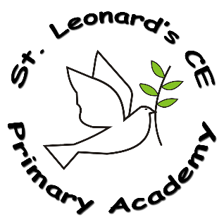

**Intent:**

**What do we want children to learn?**

At St Leonard’s we aim for our children to develop a good knowledge and understanding of Britain’s past, as well as that of the wider world. We want our children to know and understand history as a coherent, chronological narrative, from the earliest times to the present day. To know and understand how people’s lives have shaped Britain, and how Britain has influenced, and been influenced by, the wider world.

**History in a Nutshell**

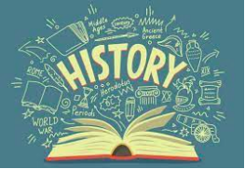

**St Leonard’s CE Primary Academy**

**Impact:**

**On leaving ST Leonard’s CE Primary Academy children will:**

Children at St Leonard’s will be able to demonstrate a broad and balanced knowledge and understanding of the primary history curriculum. They will be able to articulate this K&U, and evidence can be seen in their history books. Children will have developed an understanding and appreciation of their place in history, and the complexity of people’s lives. They will have learned about the diversity of societies, and the relationships between different groups.

**Implementation:**

**How do we do it at ST Leonard’s CE Primary Academy?**

History is taught in half termly units throughout the school year. Our programmes of study clearly identify the key knowledge and skills within each topic area to ensure consistency and progression both across topics and across each year group in the school. St Leonard’s uses a cross-curricular approach, ensuring that knowledge and understanding are rooted in context. Visits to places of historical interest are encouraged, and are used to support learning.

**What History looks like at ST Leonard’s CE Primary Academy…**

History planning is based upon National Curriculum statements. Knowledge Organisers are available for each topic in all year groups for children to refer to throughout their learning. Children become competent in historical skills by: developing an enquiring mind; by developing research skills using books, artefacts, the internet and visiting historical sites.