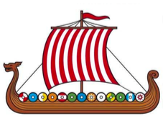
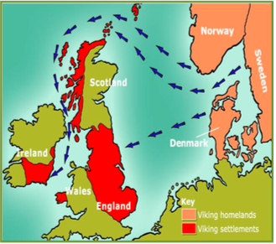
Key questions:
- Who were the Vikings – how do historians know about the Vikings?
- Which sort of historical source is most reliable?
- Where were the Vikings from?
- What made the Vikings successful?

Legacy
This topic will link to our ‘legacy’ driver, as we find out about the legacies that the Vikings left before us – with land, warfare and trade.
Year 5 Term 4: The Vikings

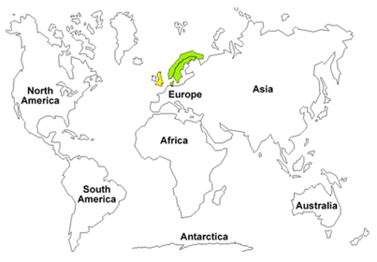
1100AD End of the Viking age

Vocabulary

Monastery A building where people worship and devote their time to God.
Missionaries People sent to promote religions, especially Christianity.
Scandinavia The area is made up of the countries: Denmark, Sweden and Norway.
Settlement A place where people have come to live.
Conquer To get something by force.
Pagan A person who believes in many Gods.
Kingdom A country whose ruler is a King or Queen.
Runes Viking letters of the alphabet.
Viking longship A ship used by Vikings for raids.
Danelaw The area in Britain the Vikings ruled.
Realm Space or area.
Ritual Ceremony of series of acts always performed in the same way.
Treaty A written agreement between two states.
Massacre Killing of many people.
Beserker Terrifying Viking warriors.
Valhalla The Vikings believe they go to this place after death
Viking Raid A surprise attack
Knarr A Viking trading ship
Danegeld Land tax to raise funds for protection against Vikings.
Excavation To uncover by digging
Archeologist An expert who studies objects from the past
Key Facts and Dates
Where do the Vikings fit into our timeline? | - AD410 – Romans left Britain  - AD459 – Angles and Saxons invaded England  - AD597 – Pope sent Augustine to spread Christianity  - AD616 – King Ethelberht died (first Christian King)
Who were the Vikings? | - 787AD – First Viking attack on Britain  - 793AD – Attack on Lindisforne  - 876AD – Guthrum, Viking King, attacks Wessex  - 878AD – Battle at Chippenham  - 878AD – Peace Treaty between King Alfred & King Gunthrum
Who were the Viking Kings? | - 899AD – King Alfred died  - 924AD – Athelston became King of Mercia  - 927AD – Athelston conquered York  - 928AD – Athelston became King of England  - 937AD – Battle of Brunanbuch  - 939AD – King Athelston died  - 978AD – Aethelred became King  - 1002AD – King Aethelred ordered all Danish men to be killed.  - 1013AD – Swedish King, Sven, became King of England  - 1016AD – Danish King, King Cnut became King of England  - 1042AD – Edward the confessor became King of England and died January 1066 – Herald II became King of England  - 1066AD – October – Battle of Hastings  - 1066AD – Duke William of Normandy became King of England

