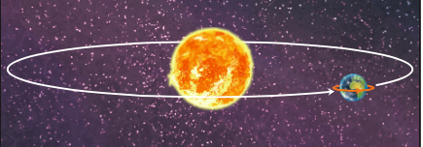
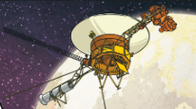
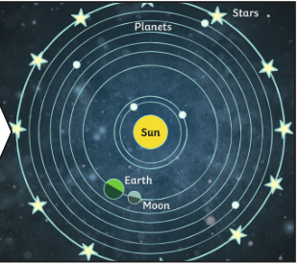
Key questions:
- Explore the solar system and its planets
- The heliocentric model of the solar system
- Earths movement in space
- Earths rotation – night and day
- Movement of the moon

Year 5 Topic: Earth & Space
Enquiry

This topic will link to our ‘enquiry’ driver, as we find out about how Earth and Space correlate to one another. How Scientists carry out investigations and observations to prove theories.

Key Facts and Dates
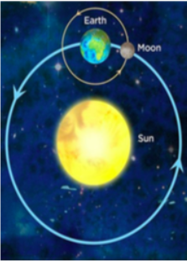  The Sun and Moon | -The Sun is a star: a huge ball of hot gas that gives off light and heat. The Earth and all planets orbit the Sun.  -It takes just over 365 days to make one orbit around the sun – 1 year.  -The Earth and planets are held in place around the Sun by gravity.  -The Earth is always spinning around. When Earth is facing the Sun it’s day. When facing away it’s night. It takes 24 hours to complete a spin.  -Some objects orbit around the planets; these are moons. The Earth has 1 moon. The moon is much smaller than the Earth, and takes one full day to complete an orbit around the Earth.
The Solar System | -The solar system includes the Sun and all of the objects that orbit around it due to gravity.  -The 5 dwarf planets are: Haumea, Makemake, Ceres, Eris and Pluto.  -Earth is the only known planet in the solar system with living things. Planets closer to the sun are thought to be too hot and planets further away are too cold.  -You could fit roughly 1.3 million Earths into the Sun!  -Many of the planets have moons. Jupiter has around 80 moons!  The stars in our galaxy are called The Milky Way. The Milky Way is one of billions of galaxies in the universe!
Planet facts | 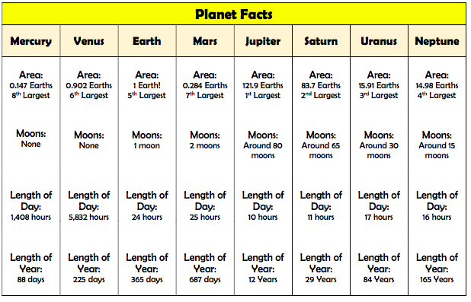
What you should already know…
- The Earth (our planet) is a part of the solar system. At the centre of the Solar System is the Sun. The Sun is a star
- There are 8 planets and 5 dwarf planets in the Solar System, which orbit (go around) the Sun.
- The Earth rotates on its axis once every 24 hours (one day). This causes day and night, as different parts of the planet face the Sun.
- The Moon orbits around the Earth. The Sun, Earth and Moon are all roughly spherical.
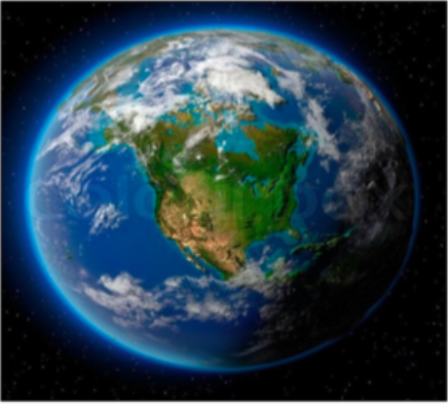

Vocabulary
Solar system The name for the Sun and all the planets and objects that orbit it.
Orbit The process of new living things being made.
Axis An imaginary line that a body rotates around. E.g. Earth’s axis (imaginary line) runs from the North Pole to the South Pole.
Geocentric A belief people used to have that other planets and the Sun orbited around the Earth.
Heliocentric The structure of the Solar System where the planets orbit the Sun
Astronomy The study of space, planets and the universe as a whole.
Terrestrial The name given to the 4 inner rocky planets – Mercury, Venus, Earth
Planet and Mars.
Gas giants The name given to the four outer planets, Jupiter, Saturn, Uranus and Neptune.
Moon A body which orbits a planet; also called a natural satellite.
Phase The appearance of a moon or planet, according to the amount of illumination.
Waxing The name given to the moon phases when the moon is getting brighter.
Waning The name given to the moon hases when the moon is getting darker.

