

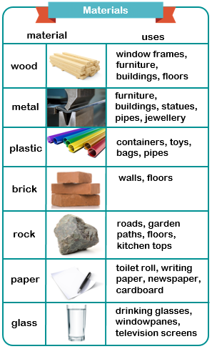

**This topic will link to our resilience and sustainability drivers as we learn about different materials and their uses in everyday life.**

**Key questions:**

What do we use different materials for?

What are the strongest materials?

What happens to solid materials when they are stretched?

What happens to solid materials when they are squashed, stretched, bent or twisted?

Which materials are waterproof?

Which material is more suitable to build a road?

Year 2 Science: Use of Everyday Materials



**Vocabulary**

|  |  |
| --- | --- |
| **material** | anything that is used to make something else |
| **property** | the way in which a material is described |
| **obstacle** | something that blocks the way |
| **construction** | the process of building something |
| **stretchy** | something that can pull apart without breaking; elastic |
| **elastic** | something that can pull apart without breaking; stretchy |
| **force** | a pressure applied to something that makes it change shape or move |
| **bend** | to shape or force something into a curved shape |

**Forces**

