

**World Continents and Oceans**

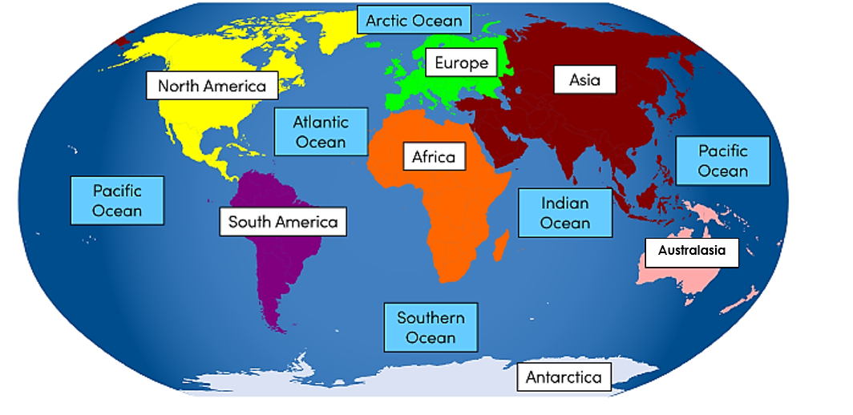

**Key questions:**

What and where are the world’s continents and oceans?

What are the geographical features of the continents?

What are the 4 main compass points?

Where is Chembakolli? And how is it similar or different to Blunsdon?

What are the key geographical features of Chembakolli?

What facts do I know about Chembakolli?

**This topic will link to our enquiry and community drivers as we learn about our local environment alongside the wider world.**

Year 2 Topic: Here We Are: A study of Oceans and Continents



**Vocabulary**

|  |  |
| --- | --- |
| **continent** | A very large area of land that includes all the islands with it. |
| **ocean** | A large area of sea. |
| **population** | The number of people that live in a particular place. |
| **landmark** | A well-known building or place. |
| **Australasia** | The continent of Australasia is often referred to as just Australia. It has about 28 counties and island groups |
| **compass** | A tool which shows which direction you are travelling in and helps you find their way. The main compass points are north, south, east and west. |
| **climate** | The usual weather conditions of an area. |
| **equator** | An imaginary line drawn around the middle of Earth, dividing it into the Northern and Southern Hemispheres, |
| **tropical** | Hot and humid. |
| **temperate** | Mild weather. Neither very hot nor very cold. |
| **polar** | Extremely cold weather. |
| **capital city** | An important city, often where the government works. |
| **currency** | The money used in a country. |
| **cuisine** | Traditional food of a country. |
| **aerial** | Seen from above. |
| **Chembakolli** | A village in the south of India. |

**Chembakolli**

How is Chembakolli similar to Blunsdon? How is it different?

4 main compass points: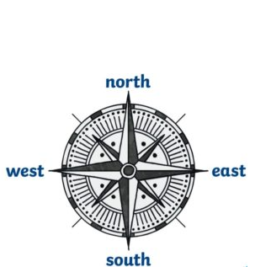

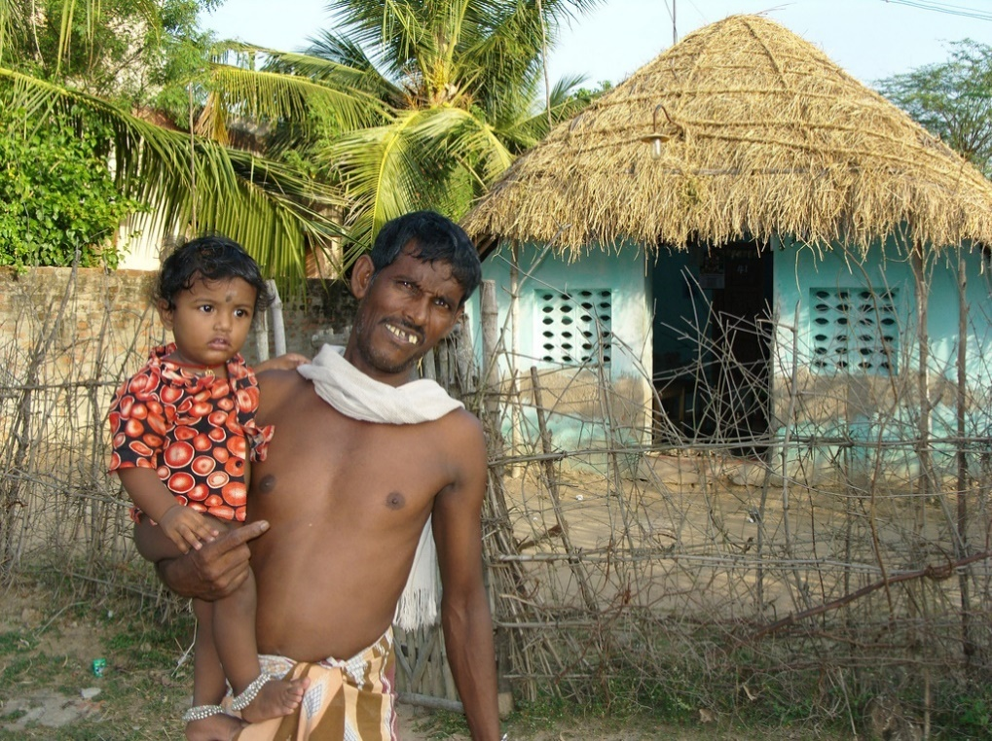

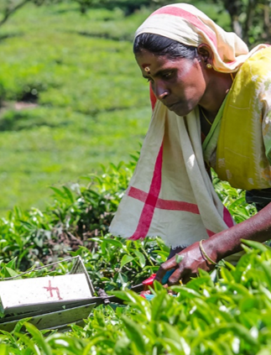

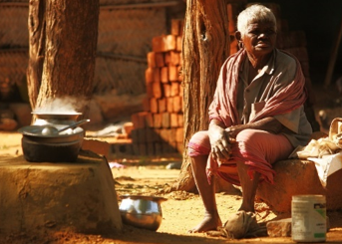

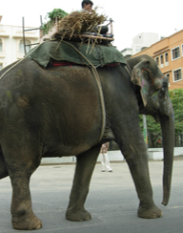

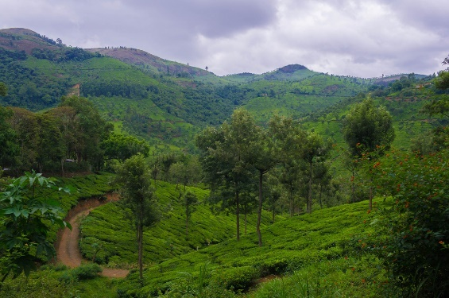

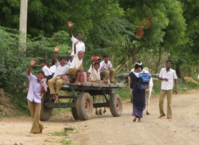





**Did you know?**

There are many methods to remember the order of the compass points:

* **N**ever **E**at **S**hredded **W**heat
* **N**aughty **E**lephants **S**quirt **W**ater
* **N**ever **E**at **S**limy **W**orms

Can you think of any others?