Science Year 4 – Nature and the Environment

Key questions:
- What is the balance of nature?
- How do environmental changes affect ecosystems?
- How does air pollution affect the environment and how can we help protect it?
- What is water pollution?
- How can we help to conserve water?
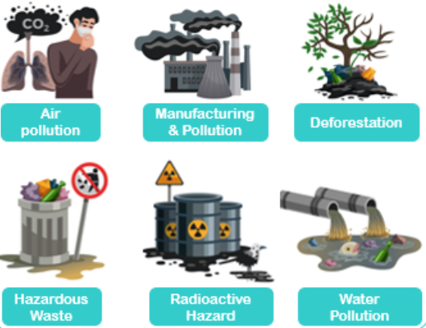
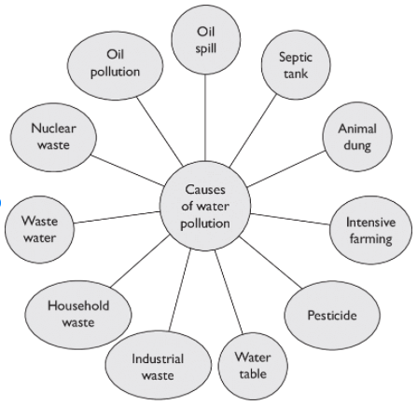
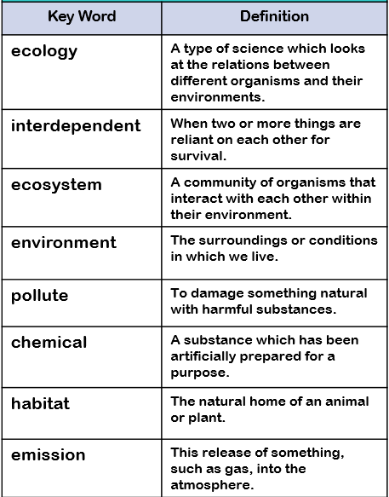
Did you know that around 450 million litres of water are wasted each year in the UK?
This topic will link to our sustainability driver as we learn the conservation of the environment is important for all life on Earth.

Key Facts
The balance of nature within ecology is where all living things are interdependent on their need of food and secure habitats based on food chains, environment and those these can be affected by pollution, extinction and a range of environmental changes.
An ecosystem is a geographic area where plants, animals, and other organisms, as well as weather and landscape, work together to form a bubble of life. Ecosystems contain biotic or living, parts, as well as abiotic factors, or nonliving parts. Biotic factors include plants, animals, and other organisms.
Habitats can change throughout the year and this can have an effect on the plants and animals that live there.
Humans can have positive and negative effects on the environment :
Positive effects : nature reserves, ecological parks
Negative effects : litter, urban development

