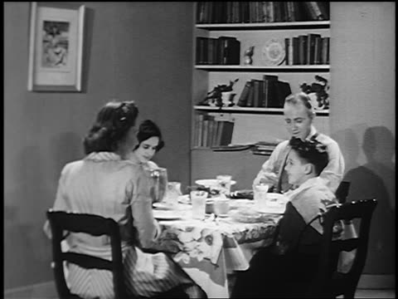
Legacy
This topic will link to our ‘legacy’ driver, as we find out about the legacies that this period of time has left us with.
Key questions:
- How have the changes in technology impacted upon our lives?
- Why did the British population suddenly rise between 1948 and 1997?
- Compare and contrast the changes in communication since 1948. Has it improved for all members of society?
- How has employment changed during this time?
- What social and political changes affected the population?

Year 6 Topic: Britain Since 1948

Vocabulary
Commonwealth – A political association of 54 countries, mostly former territories of the British Empire.
Immigrants – People who have moved to Britain for work.
Windrush – The influx of people to Britain following World War II to increase the British workforce.
Decade – A period of ten years.
Millennium – A period of 1000 years. This was widely celebrated in Britain during the year 2000.
Coronation – The act of placing a crown on the monarch’s head.
Welfare State – Money used by the government of Britain to improve health, education, employment and social security for everyone.
Space Race – Competition between USA and USSR (now Russia) to achieve firsts in space flight.
Baby Boom – A person born in the years following WWII, where there was a temporary sharp increase in Britain’s population.
National Health Service (NHS) – A publicly-funded healthcare system for the U.K.
Prescriptions – An instruction written by a medical practitioner that authorizes a patient to receive a treatment.

Key Facts and Dates
Changes in Technology | Changes in technology Thanks to electricity, major advances have been made in technology. From being able to cook in the home to mass food production in factories. From how we listen to music to how we find out information.
Changes in Population | Between 1948 and 1997, the population of Britain rose from 47 million to 58 million. This is thanks to the post war ‘Baby Boom’ and the migrants of commonwealth countries such as India and The West Indies, who came to Britain during what is known as the ‘windrush’.
Changes in Communication | Pre 1948 the only means of communication was a telegram, radio or the postal service. There have been major advances in communication technology with the introduction of television, computers, mobile phones. These have brought many changes in the ways that people are able to communicate.
Changes in Employment | With the introduction of new technology the jobs available have had to change. The 1980s saw the closure of Britain’s coal mines and the decline in traditional industries to make way for new jobs such as those working with computers and in mass food production in factories.
1940’s  1950’s  1960’s  1970’s  1980’s  1990’s  2000’s | Post war, rebuilding, introduction of Welfare State. National Health Service Act is established and created. Prescriptions begin to be paid for.  Coronation of queen, rock and roll begins to influence Britain, DNA discovered, space race began, National Service becomes compulsory. The Clean Air Act.  Rise of youth culture – drugs, peace movement, flying abroad became cheaper. Economy collapsed, strikes, trouble in NI, microchip invented.  Computers, microwaves, videos more common, Falklands war.  Age of technology, National Lottery created.  Millennium celebrations, the rise of Islamic State, financial crisis.  London 2012 Olympics, vote to leave the European Union.

