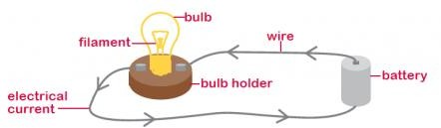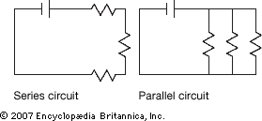Year 6 Topic: Electricity

Key questions:

1. To understand what a circuit is and how electricity flows.
2. To understand and recognise symbols when representing a simple circuit.
3. To be able to predict and test the bulb brightness depending on a variety of factors.
4. To use their knowledge from the previous objective to plan an enquiry based on bulb brightness.
5. To understand the effect of the number of cells in a circuit.

Enquiry

This topic supports the driver of enquiry through the investigation of the components of a circuit and the effect that they have when varied.

**Vocabulary**



|  |  |
| --- | --- |
| **Battery** | **A container consisting of one or more cells where**  **chemical energy is converted into electricity and used as a source of power** |
| **Bulb** | **A glass bulb which provides light by passing an**  **electrical current through a filament** |
| **Buzzer** | **An electrical device that makes a buzzing noise and is**  **used for signalling** |
| **Cell** | **A device containing electrodes that is used for**  **generating current** |
| **Circuit** | **A complete and closed path around which a circulating**  **electric current can flow** |
| **Conductor** | **A material or device which allows heat or electricity**  **to carry through** |
| **Current** | **A flow of electricity which results from the ordered**  **directional movement of electrically charged particles** |
| **Electricity** | **A form of energy resulting from the existence of**  **charged particles** |
| **Filament** | **A conducting wire or thread with a high melting point**  **that forms part of an electric bulb** |
| **Motor** | **A machine powered by electricity that supplies motive**  **power for a vehicle or other moveable device** |
| **Switch** | **A device for making and breaking the connection in an**  **electric circuit** |
| **Voltage** | **An electrical force that makes electricity move**  **through a wire, measured in volts** |
| **Battery** | **A container consisting of one or more cells where chemical energy is converted into electricity and used**  **as a source of power** |
| **Bulb** | **A glass bulb which provides light by passing an**  **electrical current through a filament** |

|  |  |
| --- | --- |
| **Key Facts and Dates** | |
| **What does a circuit need?** | **A circuit needs a source of electricity, no gaps in the circuit and have conductors so that electricity can flow.** |
| **How to vary a circuit?** | **The brightness of a bulb (brighter/dimmer) The volume of a buzzer? (louder/quieter) The speed of a motor (faster/slower)** |
| **Symbols** |  |
| **A series circuit** | A series circuit is one that has more than one resistor, but only one path through which the electricity (electrons) flows All the components in a series circuit are  connected end-to-end. A resistor in a circuit is anything that uses some of the power from the cell. In the example below, the resistors are the bulbs. |
| **A parallel circuit** | In a parallel circuit the current is divided into separate paths. In the illustration, the two upright lines in each circuit represent a power  source, such as a battery. |