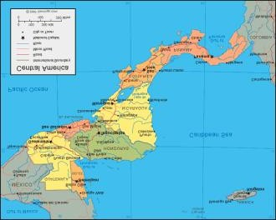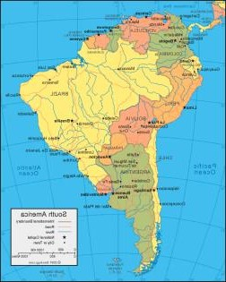Year 6 Topic: The Americas

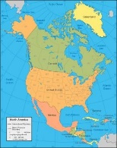

|  |  |
| --- | --- |
| **Key Facts and Dates** | |
| **North America** | USA divided into states. • Canada divided into provinces • USA has 50 states •  There are 10 provinces in Canada. • About 38 times larger than the UK  North America can be divided into five physical regions: the mountainous west, the Great Plains, the Canadian Shield, the varied eastern region, and the Caribbean. Mexico and Central America’s western coast are connected to the mountainous west, while its lowlands and coastal plains extend into the eastern region.  Within these regions are all the major types of biomes in the world. A biome is a community of animals and plants spreading over an extensive area with a relatively uniform climate. Some diverse biomes represented in North America  include desert, grassland, tundra, and coral reefs. |
| **Central America** | Part of the North America continent. • Weather - Tropical, wet summers and dry winters – the same in the Caribbean. • Mayans came from Mexico. • Panama canal makes trade easier.  The topography of Central America is mainly dominated by lush tropical forests, fertile plain lands and volcanic peaks. While Costa Rica is home to 42 active volcanoes and 60 dormant or extinct ones, Nicaragua contains the Nicaragua  Depression, which includes the huge lakes Nicaragua and Managua. |
| **South America** | It is the fourth largest continent. • Higher areas (mountainous) do get cold and drop below freezing. • Landmarks Amazon rainforest, Atacama desert, Amazon river, Andes mountains. There are five time zones in South America. The Amazon River is 6400KM long (the second longest river in the World). The Amazon River starts in the high Andes, Peru. The equator runs through the South American countries Ecuador, Brazil and Columbia. The climate zone for the Rain Forest is “tropical-wet” and the biome is “tropical-forest”. The Rain Forest is divided into four sections: They are (from highest to lowest) the emergent, canopy, understory and forest floor.  The topography of South America has been described to resemble a bowl - it has large mountains around its periphery and an interior that is relatively flat. The continent is mostly made up of lowlands, highlands, and the Andes mountain range, which is the longest mountain range in the world |

|  |  |
| --- | --- |
| **Amazon Basin** | **The area drained by the River Amazon and all its tributaries** |
| **Amazon River** | **The longest river in South America. It flows through Peru, Bolivia, Venezuela, Colombia, Ecuador and Brazil** |
| **Compass Points** | **Points on a magnetic compass marking the four main**  **directions: North, South, East, West, and intermediate directions.** |
| **Prairie** | **An ecosystem with grasslands and shrub lands where, rather than trees, many types of grasses and shrubs**  **grow well in the temperate climate.** |
| **Colony** | **A group of people from one country who build a settlement in another territory or land.** |
| **Province** | **A district, territory or region.** |
| **State** | **A nation or territory considered as an organized political community under one government.** |
| **Mountain Range** | **A chain of mountains** |
| **Topography** | **The study of the shape and features of land surfaces.** |

**Vocabulary**

Key Objectives:

1. The Americas – what are the topographical differences between them?
2. Location: To know the geographical location and characteristics of three places in South Americas.
3. Weather and Climate: *Describe and understand key aspects of physical geography, including climate zones and biomes.*
4. **Comparing Places – UK Fieldwork:** *Use fieldwork to observe, measure and record the human and physical features in the local area*
5. **Comparing Places – UK Fieldwork:** *Use fieldwork to observe, measure and record the human and physical features in the local area.* To understand geographical similarities and differences through the study of human and physical geography of a region of the United Kingdom and a region within South America.

Enquiry

This topic supports the driver of enquiry through the location of countries, cities and key topographical features.