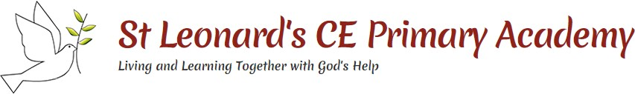Year 6 Topic: War or Peace?

**Key Questions:**

1. I can explain the geographical features of the Middle East. I can explain what I know about WW2.
2. I can describe what the UN is and some of the work it does. I can explain why Jerusalem is important to Christians, Muslims and Jews.
3. I can describe chronologically the build up to the Holocaust.
4. I can describe some facts about Anne Frank and explain why her diary is important to understanding Jewish persecution under the Nazis.
5. I can describe the key events which lead up to the outbreak of World War II.
6. I can explain my own opinions about how The Blitz affected Britain using a range of sources.
7. I can explain when, where and why children were evacuated during World War II.

I can explain the impact of the work carried out at Coleshill.

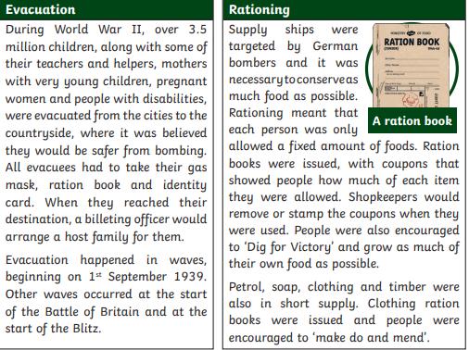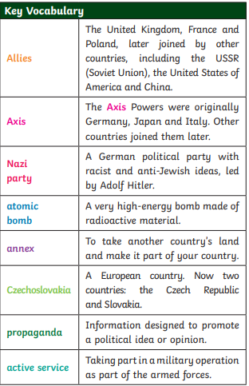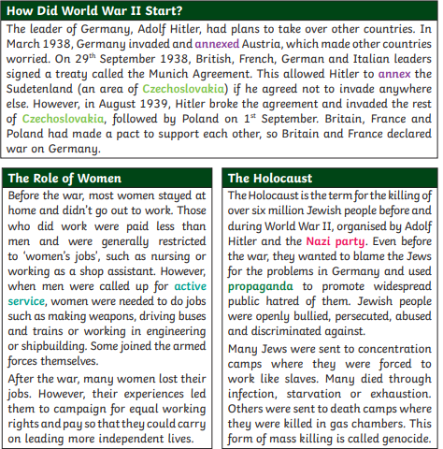

Resilience

This topic will link to our ‘**resilience’** driver, as we find out about the community of Coleshill and how they worked together ‘in secret’ to help their country.