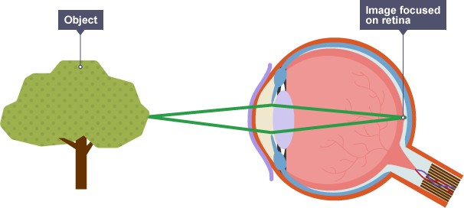Year 6 Topic: Light

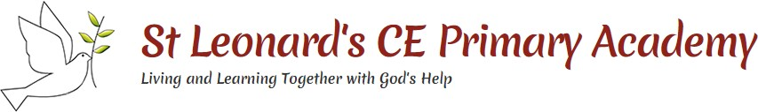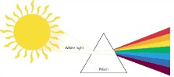

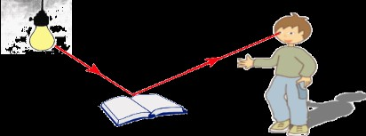

Vocabulary

Eyes – Globular organs of sight in the head of humans and vertebrate animals.

Filter – Pass through a device to remove unwanted material (liquid, gas, light or sound).

Light – The natural agent that stimulates sight and makes things visible.

Light source – Something that provides light, whether it be a natural or artificial source of light (e.g. the sun, a torch). Periscope – An apparatus consisting of a tube of attached to a set of mirrors or prisms through which an observer can see things that are otherwise out of sight.

Rainbow – An arch of colours visible in the sky, caused by the refraction and dispersion of the sun’s light by rain or other water droplets in the atmosphere.

Reflection – The throwing back by a body or surface of light, heat or sound without absorbing it.

Refraction – The bending of light as it passes from one substance to another with the bending caused by the difference in density between two substances.

Shadow – A dark area or shape produced by a body coming between rays of light and a surface.

Spectrum – A band of colours, as seen in rainbows, produced by Separation of the components of light by their different degrees of refraction.

Translucent – A material that allows some light to pass through. Transparent – A material that allows all light to pass through. Opaque – A material that doesn’t allow light to pass through.

Key questions:

* I can explain how light travels.
* I can explain that we see things because light travels from light sources to our eyes or from light sources to objects and then to our eyes.
* I can use the idea that light travels in straight lines to explain that objects are seen because they give out or reflect light into the eye.
* I can use the idea that light travels in straight lines to explain why shadows have the same shape as the objects that cast them.
* I can use the idea that light travels in straight lines to investigate how the shadow of an object can be changed.
* I can explore refraction of light

Enquiry

This topic supports the driver of enquiry as the children will investigate how the light sources are affected by objects within their pathway and how we see.

|  |  |
| --- | --- |
| **Key Facts and Dates** | |
| How does light appear to travel in straight lines? | Light waves travel out from light sources in straight lines. These lines are often called waves or beams of light.  Light travels as a wave but unlike waves of water or a sound wave, it does not need a medium to travel through. This means that light can travel through a vacuum – a completely airless space. |
| How do we see things? | We need light to be able to see things. Light from the sun travels in a straight line and hits the object. The light ray is then reflected off the object and travels in a straight line to the person’s eye. This allows the person to see the object. |
| Why do shadows have the same shape as objects that cast them? | A shadow is always the same shape as the object that casts it. This is because when an opaque object is in the path of light travelling from a light source, it will block the light rays that hit it, while the rest of the light can continue travelling. Shadows can also be elongated or shortened depending upon the angle of the light source. A shadow is also larger when the object is closer to the light source. This is because it blocks more of the light. |
| What is the law of reflection? | The law of reflection states that the angle of incidence is equal to the angle of reflection. Whenever light is reflected from a surface, it obeys this law. The angle of reflection is the angle between the normal line and the incident ray of light. |