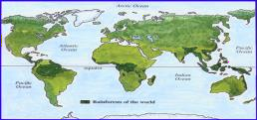Year 6 Topic: Sustainability

Key Objectives:

* Identify and label on maps and globes locations where rainforests can be found.
* Identify and label the 4 layers/strata of a rainforest.
* Identify the different plants you find in the rainforest, specific to the 4 layers.
* Identify at least 3 animals that live in the Amazon Rainforest.
* Understand and explain what deforestation is. Understand and describe the reasons for the destruction of the Rainforest
* Explain why rainforests are so important to our earth.

**Vocabulary**

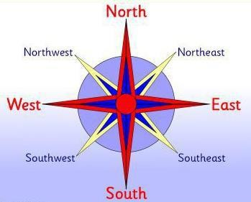

Sustainability

This topic supports the driver of sustainability through the research of the role that rainforests play within the protection of our world.

|  |  |
| --- | --- |
| **Key Facts and Dates** | |
| **The average temp of the rainforest is between 70**  **and 85 degrees**  **Farenheit.** | **Rainforests are the forests that receive high amounts of rainfall. Rainforests only cover about 2% of the Earth but 50% of the plants and animals on Earth live and grow in the rainforest. There are several types of rainforest. The world’s largest rainforest is the Amazon. Much of the life in a rainforest is found in the trees. Rainforests are in many countries- South America, Alaska, Canada, Asia, Africa. Rainforests are found in all the different continents**  **except for Antarctica as it is far too cold.** |
| **Earth’s average surface air temperature has increased by about one degree since**  **1900.** | **Over time, global climate change and more deforestation will likely lead to increased temperatures and changing rain patterns in the Amazon which will then affect water availability, biodiversity, agriculture and human health.**  **The Earth is getting warmer? Carbon dioxide levels are increasing. Extreme weather conditions.** |
| **Products from rainforests.** | **Industry – rubber, oils, gum, waxes, flavourings and dyes.**  **Medicine – Many plants can provide cures for diseases e.g. Rosy Periwinkle. Food – Many grains and fruits grow in the rainforests.** |
| **The first formal Fair Trade shop opened in**  **1958 in the U.S.** | **Fair trade is a way of buying and selling products that allows farmers to be paid a good price for their product and have better working conditions; enabling farmers to continue their work.** |
| **Recycling a single 500 ml aluminium beer can saves enough energy to power a TV for over 4**  **hours.** | **Rainforests are essential to life on Earth. Not only do they provide air, water, medicine, food, and shelter to a multitude of living beings, they are also one of our best natural defenses against climate change because of their capacity to absorb greenhouse gases from the atmosphere**. |

|  |  |
| --- | --- |
| Temperate | Mild, moderate. |
| Ecosystem | A community of plants and animals that depend upon each other to survive. |
| Compass Points | Points on a magnetic compass marking the four main directions: North, South, East, West, and intermediate directions. |
| Prime Greenwich Meridian/Time zones | Time zones are divided by imaginary lines called  meridians which run from the North Pole to the South Pole. |
| Latitude | Imaginary horizontal line used to show NSS position on  the Earth’s surface |
| Longitude | Imaginary vertical line used to show E-W position on the  Earth’s surface |
| Deforestation | The action of clearing a wide area of trees. |
| Habitat | The natural home or environment of an animal, plant or organism. |
| Fair Trade | A way of buying and selling products that allows farmers to be paid a good price and have better working  conditions. |
| Rainforest | A luxuriant, dense forest rich in biodiversity, found typically in tropical areas with consistently heavy rainfall. |
| Interdependent | When two or more people or things rely on each other. |
| Equator | Imaginary line through the middle of the Earth that receives the most sunlight. |
| Tropic of Cancer Tropic of Capricorn | Imaginary lines North and South of the Equator. Most rainforests can be found between these lines. |