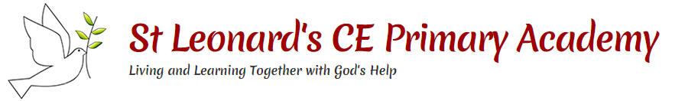

**This topic will link to our Resilience and Sustainability drivers as we explore what animals, including humans need to survive and to protect themselves.**

**Key questions:**

How do living things get food?

Why do we need food?

Why is it important to be healthy?

What are vertebrates and invertebrates?

Why do we have bones?

How do our muscles work?

**Vocabulary**

|  |  |
| --- | --- |
| healthy | In a good physical and mental condition |
| nutrients | Substances that animals need to stay alive and healthy |
| energy | Strength to be able to move and grow |
| saturated fats | Types of fats – considered to be less healthy and should only be eaten in small amounts |
| unsaturated fats | Fats that give you energy, vitamins and minerals |
| vertebrate | Animals **with** backbones |
| invertebrate | Animals **without** backbones |
| muscles | Soft tissues in the body that contract and relax to cause movement |
| tendons | Cords that join muscles to bone |
| joints | Areas where two or more bones are fitted together |



Year 3 Science: Animals Including Humans

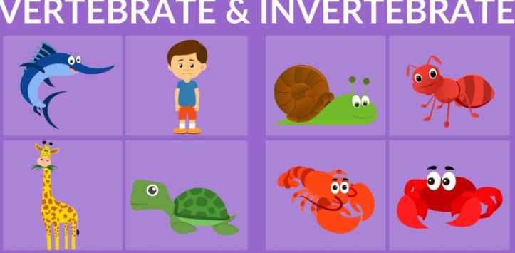

Skeletal muscles work in pairs to move the bones they are attached to, by taking turns to contract (get shorter) and relax (get longer)

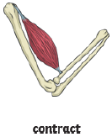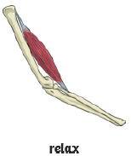

**Skeletons do three important jobs**:

-Protect organs inside the body

-Allow movement

-Support the body and stop it from falling on the floor.



Did you know?

* Living things need food to grow and to be strong and healthy
* Plants can make their own food, but animals cannot
* To stay healthy, humans need to exercise, eat a healthy diet and be hygienic
* Animals, including humans, need food, water and air to stay alive

