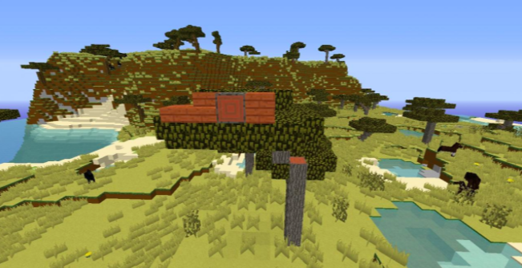
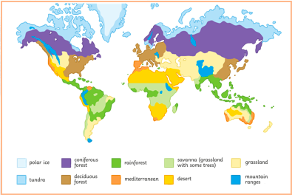
Sustainability
This topic will link to our ‘sustainability’ driver, as we find out about how our lifestyle is affecting climate zones and natural biomes.
Key questions:
- What is a climate zone?
- Where are the different climate zones?
- What is a Biome?
- Where are the different Biomes?
- What is the link between Climate zones and Biomes?

Year 5 Topic: Climate Zones & Biomes

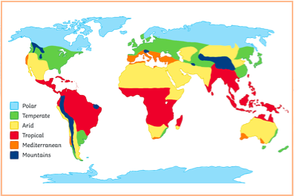
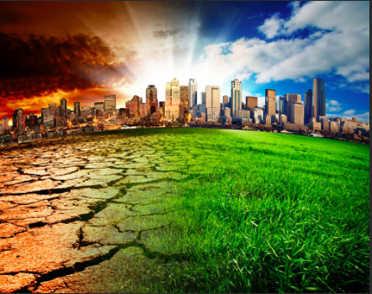

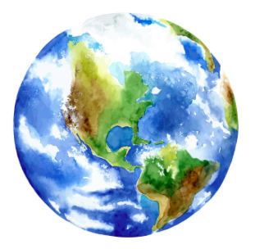
Vocabulary
Climate The long term weather conditions of an area.
Climate Change Changes in the earth’s climate, especially the gradual rise in temperature, as a result of human activity.
Climate Zone Sections of the Earth that are divided according to the planet.
There are 3 main climate zones; polar, temperate and tropical.
Biome A natural area of vegetation and animals.
Vegetation Plants, trees and flowers.
Equator An imaginary circle around the middle of the Earth.
Biotic Living factors in an ecosystem (tress, flowers, animals etc).
Abiotic Non-living factors in an ecosystem (rocks, sun, precipitation, soil).
Adaptation A behavior or physical characteristics that allows an organism to survive or reproduce in its environment.
Rainforest Biome which is hot and wet all year round. They are home to half of all the different types of plants and animals on the planet.
Desert Dry areas that receive very little rain.
Grasslands Areas of land that are vast and open, with grasses being the main
plants.
Savannah A biome that is hot all year round with a long, dry season.
Tundra A large, barren region with no trees. The coldest of all the biomes.
Taiga Colder climate region. Cold snowy winters and rainy summers warm
Enough to melt the snow.
Temperate An area that has all 4 seasons and contains trees that shed their leaves and grow new ones each year.

Key Facts and Information
Climate Zones | The weather changes in different parts of the world. Where there are similar weather patterns this is known as a climate. At the top of the Earth there is an arctic climate and some of the coldest temperatures in the world are found here. Temperate climates are found a bit further south, and as you approach the equator you find Mediterranean and desert climates. Some of the hottest places on Earth are found here, and few people live in this climate. At the equator there is a tropical climate, and travelling south of the equator it gets cooler again before reaching the Antarctic.
The equator | The equator is an imaginary line that divides the Earth in half. The equator is an equal distance between the North and South Poles. The weather on the equator is hot all year round. At the equator, day and night are both 12 hours long. The time it takes for the sun to set and rise at the Equator is the fastest on Earth. The change from day to night takes only a few minutes.
What is a Biome? | A biome is a natural area of plants and animals. The world is divided into lots of different biomes and they are all different depending on their climate.
Fires in the Savannah | Fires are an important part of the savannah. During the dry season fires clear out old dead grass and make way for new growth. The  https://www.bbc.co.uk/bitesize/topics/z849q6f/articles/z7dkhbk  https://www.bbc.co.uk/bitesize/topics/z849q6f/articles/zvsp92p  https://www.ducksters.com/science/ecosystems/world_biomes.php

