

**This topic will link to our Resilience, Enquiry and Perseverance drivers as we explore different forces and magnets and magnetic materials.**

**Key questions:**

What are forces?

What are the effects of friction on different surfaces?

What are magnetic and non-magnetic materials?

How can you test the strength of a magnet?

What are magnetic poles?

**Vocabulary**

|  |  |
| --- | --- |
| forces | Pushes or pulls. |
| friction | A force that acts between two surfaces or objects that are moving, or trying to move, across each other. |
| surface | The top layer of something. |
| magnet | An object which produces a magnetic force that pulls a certain object towards it. |
| magnetic | Objects which are attracted to a magnet are magnetic. Objects containing iron, nickel or cobalt metals are magnetic. |
| magnetic field | The area around a magnet where there is a magnetic force which will pull magnetic objects towards the magnet. |
| poles | North and south poles are found at different ends of a magnet. |
| repel | Repulsion is a force that pushes objects away. For example, when a north pole is placed near the north pole of another magnet, the two poles repel (push away from each other). |
| attract | Attraction is a force that pulls objects together. For example, when a north pole is placed near the south pole of another magnet, the two poles attract (pull together). |



Year 3 Science: Forces and Magnets

Different surfaces create different amounts of friction. The amount of friction created by an object moving over a surface depends on the roughness of the surface and the object, and the force between them.

A magnetic field is invisible. You can see the magnetic field here though. This is what happens when iron filings are placed on top of a piece of paper with a magnet underneath.

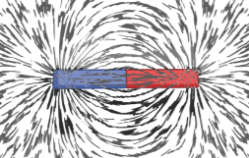

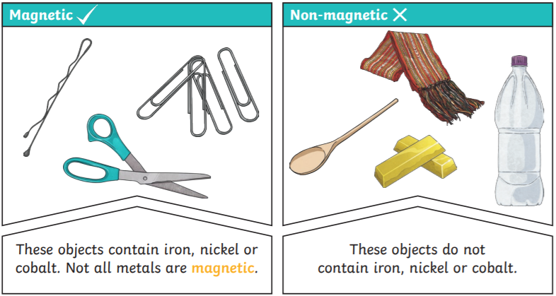



Friction pushes on the bicycle, slowing it down.

The driving force pushes the bicycle, making it move.

**Did you know?**

* Forces will change the motion of an object. They will either make it start to move, speed up, slow it down or even make it stop.
* The needle in a compass is a magnet. A compass always points north-south on Earth.
* Magnets have a pole at each end. Like poles repel and opposite poles attract.