Key questions:
What was life like in Britain before the Romans invaded?
Can you name any key people from Roman times?
Why did the Romans invade Britain?
Why were the Romans so successful? (Research)
Why were the Romans so successful? (Informative text)
How did the Roman invasion of change Britain?
Vocabulary

Invasion – One country attacking another to take over it.

Legion – One unit in the Roman army. Had 4000 to 6000 soldiers in it, Led by a Centurion.

Emperor – The leader of an empire. Similar to a king or queen.

Celts – The people living in Britain prior to the invasion.

Caledonia – The Roman name for Scotland.

Hadrian’s Wall – A wall built at the border / edge of the Roman Empire.

Mosaic – A picture made up of thousands of small tiles (tessellates).

Villa – A Roman country house.

Senate – The Roman Government.

Civilised – Organised, cultured and educated.

Strategy – a plan of action designed to achieve a long term or overall aim.

Key Facts and Dates
Romans begin invasion of Britain | In AD 43, the Roman emperor Claudius launched an invasion of Britain, and over the next 45 years the Roman army gradually extended its control over much of present-day England and Wales and ventured into territory now in Scotland.
Julius Caesar | Famous Roman Leader who led the invasion of Britain  First attempt was in 55BC
Emperor Claudius | Emperor who led the first successful invasion of Britain in 43AD
Boudicca | Saxon Queen who fought back against the Romans in 60AD
Legions | At its largest, there might have been around half a million soldiers in the Roman army. To keep such a large number of men in order, it was divided up into groups called ‘legions’. Each legion had between 4,000 and 6,000 soldiers.
Roman military strategies | Roman soldiers usually lined up for battle in a tight formation. After a terrifying burst of arrows and artillery, the Roman soldiers marched at a slow steady pace towards the enemy. At the last minute, they hurled their javelins and drew their swords, before charging into the enemy. Then they used cavalry (soldiers riding horses) to chase anyone who tried to run away.
End of the Roman Invasion | Romans leave Britain and return to Italy in 410AD  They left a lot of changes to Britain.

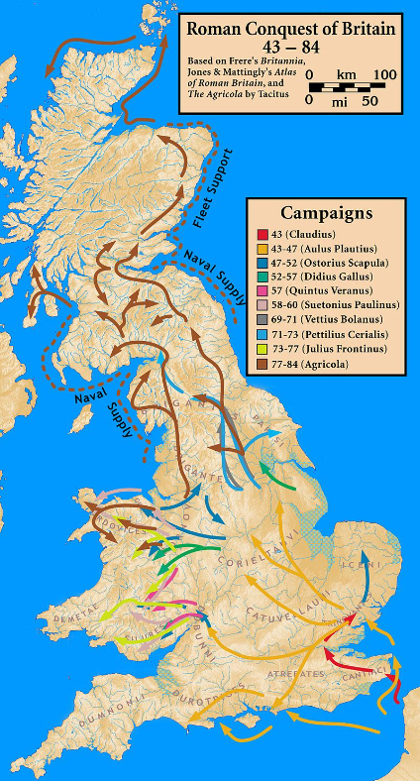
This topic will link to our Legacy and Tolerance drivers as we find out how after the Roman invasion there were many changes to the infrastructure, organisation and society of our country.

