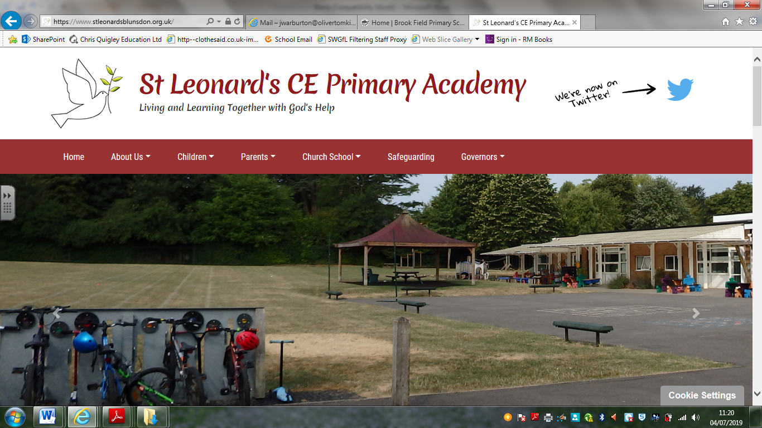**Teaching and Learning Policy**

**Sept 2025-2026**

This policy should be read in line with our schools’ vision statement, ‘**Living and Learning Together with God’s Help**’, as it encompasses everything that we do. It stems from the Christian belief that all children are to believe in themselves, *being a unique human being, made by God and Loved by him,*and so develop a love of lifelong learning and a sense of community, as we grow together as part of God’s family; being with God and having his help as we live and learn together in all that we are and seek to be.

**Setting High Expectations**

**Intent**

We will provide our children with the knowledge, attitudes, skills and habits (KASH) they need, in order to achieve their goals.

**Implementation**

Setting high expectations plays an integral part in our learning provision.

We understand that different learners need to be catered for in different ways. It is essential that a strong community is built in each of our classrooms and across the school where children support each other to do well, accept each other’s differences and all want to beat their personal bests. Teachers and other adults will need to vary their approach to support the differing needs of learners and a variety of resources should be made available to the children in order to support their learning further.

**Impact**

Children will have high expectations of themselves and their learning.

**Growth Mindset**

**Intent**

We aim to develop a Growth Mindset in all children and ensure that learning is set at an appropriate level of challenge. We encourage learners to go beyond their current level and extend them further.

Diagram 1

**Implementation**

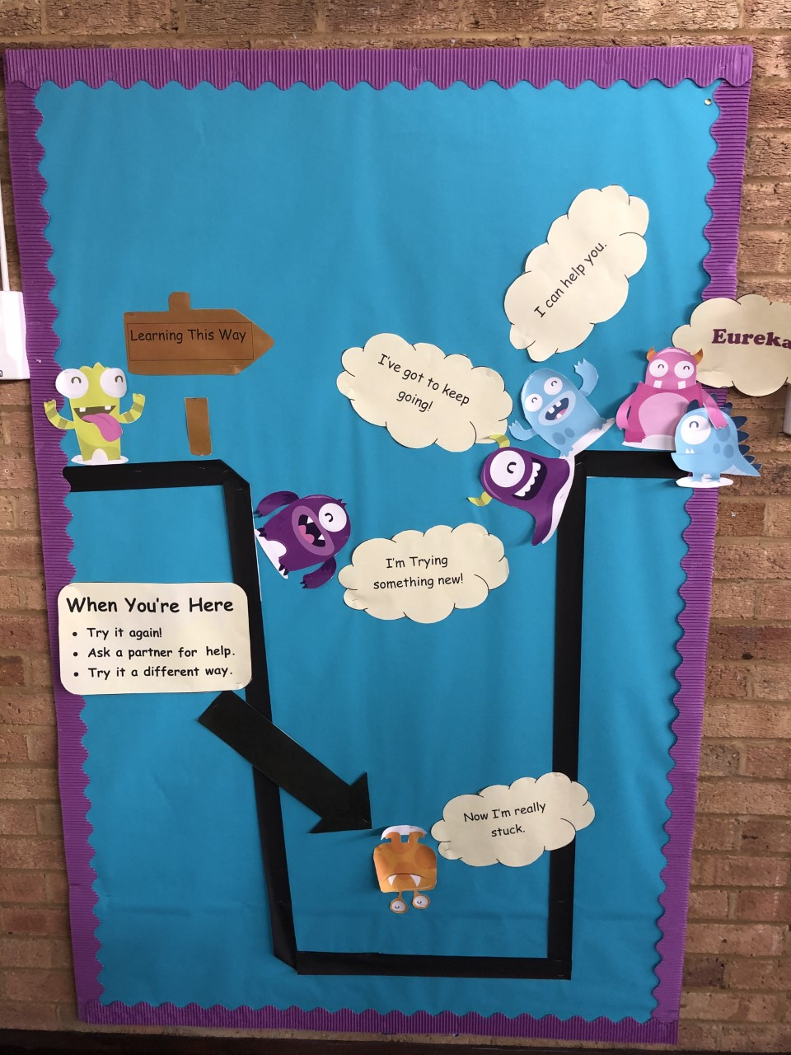The image that we use to discuss this

with the children is shown in diagram 1.

All children and staff will discuss learning in

this way, so that there is a shared and

consistent language regarding learning.

**Impact**

Children will have an attitude to learning that

enables them to go beyond their current level.

**Starting Points**

**Intent**

We aim to establish the prior knowledge and skills that a child holds in order to ensure our lessons are the most productive that they can be.

**Implementation**

Pre-assessment tasks will be integral to our planning process. Opportunities to pre-assess are built in to our planning in readiness for the next concept/ topic, alongside the use of our Knowledge Organisers in Science/ History and Geography. We will use a range of strategies to pre-asses, which include, but is not exclusive to: Concept maps/ Knowledge grids/ KWL grids/ structured observations. Pre-assessments will also be used to determine where on the journey of the Growth Mindset, each child is.

**Impact**

The differing needs of our children will be met in order for them to progress with their learning.

**Defining the Learning Destination**

**Intent**

We believe it is important for the children at our school to understand what success looks like before they start their learning of a new concept/ topic.

**Implementation**

Teachers will share excellent examples of what they are looking for from the very beginning, providing clarity which will support the confidence and motivation of each child when engaging in the learning process. There will be a multi-sensory approach to learning, as we recognise that children learn in different ways. Mastery of the knowledge and skill will then enable original thought, which will always be encouraged.

**Impact**

Providing the children with a clear and well-defined destination will support them in being successful.

**Proof of Learning**

***Intent***

We will ascertain proof of learning in a variety of ways, to gain proof of understanding, check for misconceptions that need to be addressed and challenge learners to provide evidence of their learning.

**Implementation**

A range of strategies will be used such as, questioning, presentations and assessment rubrics.

**Impact**

Part of developing Growth Mindsets in the children will be ensuring that they can each provide the evidence that demonstrates the depth of learning that has taken place.

**Challenge**

**Intent**

We believe that a crucial element of learning is the ability to remember things. Children will be provided with the opportunity to spend time thinking about the learning presented and grappling with the challenge.

**Implementation**

Creating challenge in lessons that encourage learners to experience and think about the meaning of what is being taught is crucial to learning and sense making. The level of challenge will always be set an appropriate level for each individual child.

**Impact**

The learning that takes place will enable each child to process more deeply and remember more effectively. A range of challenge frameworks will be used with the children.

**Feedback**

**Intent**

Our aim is that feedback needs to be timely, learning adapts as a result of feedback and reflecting on feedback becomes a habit. Feedback must be accurate, kind, specific and helpful. Feedback allows planning to be adapted for the learners needs. Feedback should pose a direct challenge or question for learners to act on.

**Implementation**

Teachers and Learners will provide feedback within the classroom. A shared understanding of what good feedback consists of will be established. A range of strategies will be used, to include but not exclusive to: One-one reviews, guided groups, individual and group reviews. The process of how to critique work will be modelled.

The children will develop the skills of listening to, reflecting on and acting on the feedback they’re given. We will train our learners to accurately identify where the gaps are and how they can close them, not just in their own work but in their peers too.

Learners should not compare their feedback to that of other learners.

**Impact**

Teachers and learners are able to give effective feedback in real time while continuing to learn and stay in flow. Learners will develop greater responsibility for their own learning

**Transition in the Teaching and Learning Process**

**Intent**

We recognise that Transition is a crucial time in the development of any child’s learning journey and we intend to support each child at this time.

**Implementation**

In July, each child will have time to meet and work with their class teacher for the following September, this will also be a time when pre-assessments will take place.

Discussions will be held between teachers regarding the differing need of each child and an assessment of their Growth Mindset.

We will also involve parents in identifying the strengths, interests and areas of concern for their child, at that point in time.

**Impact**

Children will feel supported and continue to develop their attitude to learning during transition.

**Policy Status and Review**

This policy was created by the Head teacher; in consultation with the teaching team, and its implementation is seen as the responsibility of all staff. Its use and effectiveness will be supported and monitored by the Head Teacher and Governors.

|  |  |
| --- | --- |
| Written by: | Headteacher |
| Owner: | Headteacher |
| Status: | Nov 2025 (pending) |
| Approval date: | September 2025 Review date: September 2026 |
|  |  |