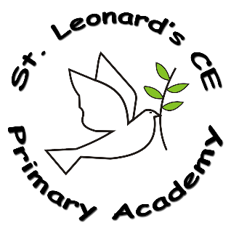

**Implementation:**

**How do we do it at ST Leonard’s CE Primary Academy?**

The teaching and implementation of the Art and DT Curriculum is based on the National Curriculum and supported by a clear skills and knowledge progression.

The teaching of DT follows the design, make and evaluate cycle. Each stage is rooted in technical knowledge, vocabulary and the design process rooted in real life, relevant contexts to give meaning to learning.

The teaching of Art enables children to record from first-hand experience and from imagination, selecting their own ideas to use in their work. It develops creativity and imagination through a range of differing activities; it improves children’s ability to control materials, tools and techniques and it increases the critical awareness of the roles and purposes of art, craft and design in different times and cultures.

**Intent:**

**What do we want children to learn?**

At St Leonard’s we enable children to experience, Art and DT through independent and cross curricular topics. The children have the opportunity to make a range of creations/ representations that fascinate them and spark imagination so that our children’s innate sense of creativity is valued and excites them. These processes encourage problem-solving skills, both as individuals and in groups, which can be applied to real life contexts. Our high-quality Art and DT education develops our drivers of resilience, perseverance, enquiry and respect.

**Art & DT in a Nutshell**

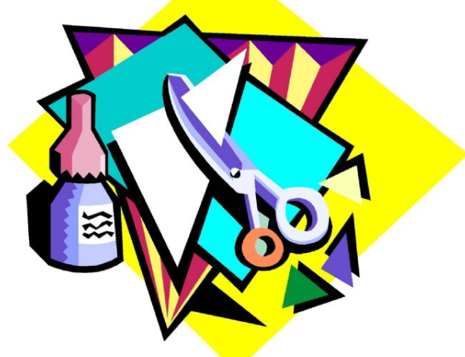

**ST Leonard’s CE Primary Academy**

**Impact:**

**On leaving ST Leonard’s CE Primary Academy children will:**

The children at our school will have the experience of learning about colours, textures and the work of various artists. They will be passionate about creating items for a given purpose and will be able to evaluate their own work, based on a given criteria.

**What Art and DT looks like at ST Leonard’s CE Primary Academy…**

At St Leonard’s we aim to involve all children within a creative process, experimenting with a range of materials and mediums in order to spur their imagination and widen their understanding of how art is created. They will be taught vital key skills which will progress as they move through the school. They will produce art in different forms: painting, drawing and sculpture and reflect on their own and their peer’s art work. The children will also become aware of a range of artists from around the world.

Design and Technology requires pupils to apply knowledge and skills to solve practical problems. It involves identifying a need, generating design ideas, planning, making and appraising. Children will learn how to take risks and become more resourceful through the use of trial and error, evaluating and editing their work. These are essential skills for our pupils to develop as they prepare to take their place as adults in society.