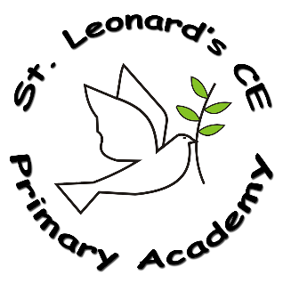

**English in a Nutshell**

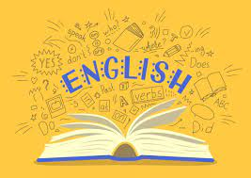

**ST Leonard’s CE Primary Academy**

**Implementation:**

**How do we do it at ST Leonard’s CE Primary Academy?**

Each year group (Y1-Y6) follows the St Leonard’s Writing Journey structure to ensure each unit is taught systematically, building on children’s prior knowledge and ensuring gaps are identified and addressed quickly.

We work on promoting a love of reading in all children and fostering a text rich environment where children understand how language works as well as develop the skills they need to be proficient readers and to interpret texts accurately. All KS2 classes (and Y2 following the end of the RWI program implement a whole-class guided reading approach where high quality texts are used to ensure all children have access to rich language and complex contexts in a supportive environment.

We follow the Read, Write, Inc (RWI) approach to teaching Reading and Phonics in EYFS/ KS1, supplemented with additional reading materials. Our approach is systematic, consistent and rigorous in order for all children to become readers as quickly as possible.

**Impact:**

**On leaving ST Leonard’s CE Primary Academy children will:**

* Be able to **effective communicators** and apply this skill with a range of audiences and situations
* Be **confident** readers who can discuss and evaluate their reading texts.
* Be **thoughtful, reflective** writers, writing for different purposes effectively and able to independently review and improve their own work.

**Intent:**

**What do we want children to learn?**

We aim to develop our children’s ability to use spoken and written language to communicate effectively – **to listen, speak, read and write with confidence and skill** in a variety of situations,

We want our children **to read fluently with good understanding**. We want our children to love reading and to want to read for themselves for pleasure sharing their reading experiences and enjoyment with others.

We want our children to acquire a **wide vocabulary**, a **good understanding of grammar in context** and to be able to spell accurately.

We want our children to write **clearly, accurately and coherently**, adapting their language and style as necessary.

**What English looks like at ST Leonard’s CE Primary Academy…**

Our English planning is based on National Curriculum Statements. In writing we use a 2 week progressive unit plan, following our Writing Journey structure to ensure consistency across the school and that each session builds on the previous one. In reading we follow a whole-class reading approach in KS2 and Y2 (after RWI). The units are planned to ensure coverage of the reading Content Domains. In Y1 and Reception, we follow the RWI programme for phonics and reading. Spelling is taught discretely on a Friday and applied across all English lessons