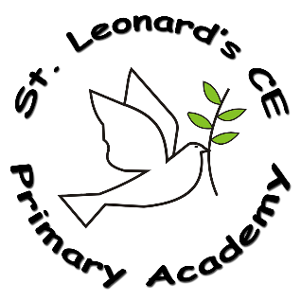

**Intent:**

**What do we want children to learn?**

At St Leonards, we recognise the importance of science in every aspect of daily life. As one of the core subjects taught in primary schools, we give the teaching and learning of science the prominence it requires. Our aim is to equip our children with the working scientific skills, knowledge and vocabulary motivated by our core skills of active learning, **enquiry** and creative thinking.

The National Curriculum shapes our Science curriculum for Science, our school curriculum, our school values and the ethos at St Leonards. Our science curriculum aims to ensure that all children:

* develop **scientific knowledge and conceptual understanding** through the specific disciplines of biology, chemistry and physics
* develop understanding of the **nature, processes and methods of science** through different types of science enquiries that help them to answer scientific questions about the world around them
* Are equipped with the **scientific skills** required to understand the **uses and implications** of science, today and for the future.

**Science in a Nutshell**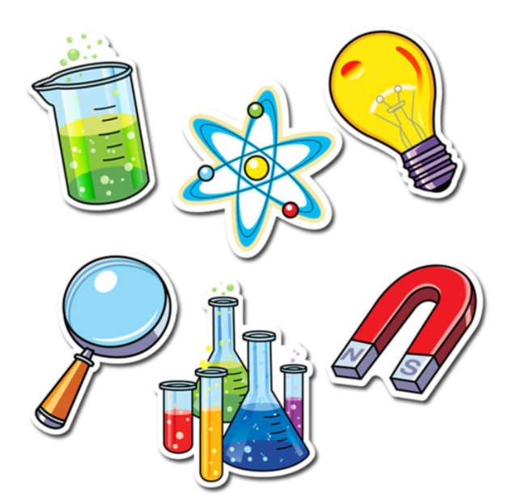

**ST Leonard’s CE Primary Academy**

**Implementation:**

**How do we do it at ST Leonard’s CE Primary Academy?**

Across the school, there is a consistent teaching sequence. Each session begins with putting new learning in the big picture, discussing how current concepts relate to any prior knowledge of previous learning. Key vocabulary to be used in the lesson and its meaning will be introduced and revisited through the use of knowledge organisers. Enquiry and Working scientifically skills will be shown with visuals in each class to show the children the skills they will focus on in that lesson. Practical resources will be used where possible, to enhance scientific enquiry. Pupils will be provided with opportunities to interpret their observations, results and conclusions; communicating their scientific knowledge and understanding appropriately, before evaluating their learning.

A wide variety of teaching approaches will be used in science lessons to ensure children make good progress; show **resilience** and all individual needs will be catered for. Knowledge organisers will be shared with the children in order to provide them with the key knowledge and language they will require. This will include subject specific vocabulary to be shared throughout the term. **Enquiry** and Working scientifically skills will be displayed in all classrooms and through recognition of these, children’s’ scientific vocabulary and explanations will allow discussions to delve deeper into the concepts.

**What Science looks like at ST Leonard’s CE Primary Academy…?**

Our Medium Term Planning each term is based on National Curriculum Statements and use of our teaching backwards approach to ensure consideration of progression in each science topic across the school. Knowledge organisers are present for each topic in all year groups for children to refer to throughout learning. Children show the expected knowledge and skills required in each session and can discuss these. Sessions will include learning about a range of scientific theories, investigations and enquiry skills they can use to understand the world around them.

**Impact:**

**On leaving ST Leonard’s CE Primary Academy children will:**

Children will have developed an enjoyment and a sense to enquire deeper into all areas of Science. They will have a positive attitude and **resilience** towards enquiry, investigation and evaluation within Science. . They will be tolerant learners who **persevere** and are ready to take their learning into the **community** and apply their scientific understanding to the world around them, seeking a better future through **sustainability**. Children will know that the use of mistakes and misconceptions is an essential part of learning and through our curriculum they will show secure knowledge and ability to recall essential information and skills covered across their time at St Leonards based on the Science coverage within the National Curriculum.