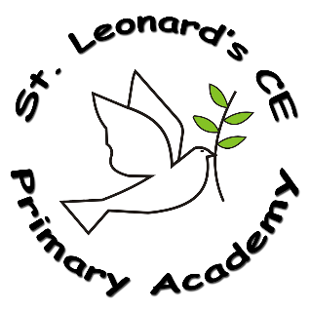

**Music in a Nutshell**



**St Leonard’s CE Primary Academy**

**Implementation:**

**How do we do it at ST Leonard’s CE Primary Academy?**

At St Leonard’s we make music an enjoyable learning experience. Our school uses the scheme Charanga for music lessons which provides both resources and lesson plans for years 1 -6. As our reception class is part of the Foundation Stage of the National Curriculum, we relate the musical aspects of the children’s work to the objectives set out in the Early Learning Goals (ELGs) which underpin the curriculum planning for children aged three to five.

Our lessons comprise of a mixture of teacher-led, whole class activities, and work for small groups and pairs. Musical games are also an important feature which help to build musical skills. Singing lies at the heart of good music teaching. Our teaching focuses on developing the children’s ability to sing in tune and with other people. Through singing and signing songs, children learn about the structure and organisation of music. We teach them to listen and to appreciate different forms of music.

**Intent:**

**What do we want children to learn?**

Our intent is to provide opportunities for our pupils to perform, listen to, review and evaluate music across a range of historical periods, genres, styles and traditions, including works of the great composers and musicians. We want them to learn to sing and use their voices, to create and compose music. We want them to understand and explore how music is created, produces and communicated.

**What Music looks like at St Leonard’s CE Primary Academy…**

Our children are encouraged to participate in a variety of musical experiences through which we aim to build up the confidence of all children. The most effective way for children to gain an understanding of music is through opportunities to explore, recognise and respond to the musical elements of pitch duration, tempo, timbre, texture and structure, as well as to create, control and record these elements.

**Impact:**

**On leaving ST Leonard’s CE Primary Academy children will:**

The children at our school will have the experience of learning to play an instrument, singing, performing, appraising and composing. Our children will have developed a passion for music which will continue to flourish alongside their musical skills and knowledge