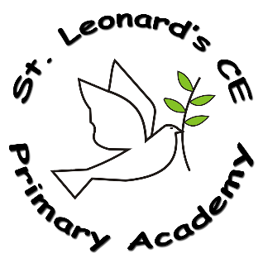

**Impact:**

**On leaving ST Leonard’s CE Primary Academy children will:**

* be able to approach a range of real life situations and apply their skills and attributes to help navigate themselves through modern life
* be on their way to becoming healthy, open minded, respectful, socially and morally responsible, active members of society
* appreciate difference and diversity
* recognise and apply the British Values of Democracy, Tolerance, Mutual respect, Rule of Law and Liberty
* be able to understand and manage their emotions
* be able to look after their mental health and well-being
* be able to develop positive, healthy relationship with their peers both now and in the future
* understand the physical aspects involved in Relationships, Sex and Health Education as an age appropriate level
* have respect for themselves and others
* have a positive self esteem

**What PSHE looks like at ST Leonard’s CE Primary Academy…**

PSHE at St Leonard’s is delivered through Jigsaw; a comprehensive programme for primary PSHE including statutory Relationships and Health Education, in a spiral, progressive scheme of work. This gives our children relevant learning experiences to help them navigate their world and to develop positive relationships with themselves and others. We have a strong emphasis on emotional literacy, building resilience and nurturing mental and physical health, including mindfulness to allow children to advance their emotional awareness, concentration and focus.

**Implementation:**

**How do we do it at ST Leonard’s CE Primary Academy?**

EYFS

* Embedded throughout the curriculum.

KS1 and KS2

* Taught in line with the national curriculum, through the Jigsaw scheme of work
* Spiral, progressive scheme of work, that aims to prepare children for life
* Strong emphasis on emotional literacy
* Elements of Sex Education and different kinds of relationships, including LGBT relationships and gender identity
* 6 half-termly themes, with each year group studying the same unit at the same time (at the relevant level)
* Identifies links to British values and SMSC and is taught in a way as to reflect the overall aims, values and ethos of our school

**PSHE in a Nutshell**

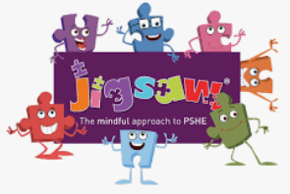

**ST Leonard’s CE Primary Academy**

**Intent:**

**What do we want children to learn?**

* Children will have high aspirations, a belief in themselves and realise that anything is possible if they put their mind to it.
* Children will learn that there are different factors which will affect their world and learn how to deal with these.
* Children will be able to access the wider curriculum and prepare them to be global citizens.
* Through the promotion of the spiritual, moral, cultural, mental and physical development, pupils will be prepared for the opportunities, responsibilities and experiences for later life.