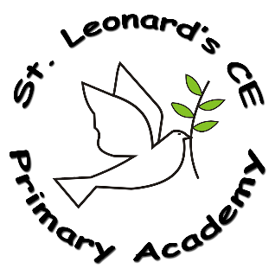

**Impact:**

**On leaving ST Leonard’s CE Primary Academy children will:**

* knowledge and understanding of, and their ability to respond to, Christianity, other world religions, religious traditions and world views
* understanding and respect for different religions, beliefs, values and traditions (including ethical life stances), through exploring issues within and between faiths
* understanding of the influence of faith and belief on individuals, societies, communities and cultures
* skills of enquiry and response through the use of religious vocabulary, questioning and empathy
* skills of reflection, expression, application, analysis and evaluation of beliefs, values and practices and the communication of personal responses to these

**Implementation:**

**How do we do it at ST Leonard’s CE Primary Academy?**

* Religious Education is taught on a weekly basis, for one hour in Key Stage 1 and 2 and 50 minutes in EYFS.
* Teachers develop key learning objectives linked to the themes in the syllabus, allowing links with other subject areas where appropriate.
* Lessons are planned and delivered in a variety of ways ensuring that all children can access and participate in lessons. Interactive, practical activities encourage the children to discuss their ideas and extend their understanding of difficult concepts and challenging questions.
* Pupils’ progress in RE is based on the expected outcomes outlined in the Swindon Agreed Syllabus and in Understanding Christianity.
* Progress in RE is reported annually to parents and has a prominent position in the end of year report.

**RE in a Nutshell**



**ST Leonard’s CE Primary Academy**

**Intent:**

**What do we want children to learn?**

* Develop an understanding of the values that underpin our ethos and why they are important.
* An opportunity to share and explore faith.
* A deep understanding of Christianity, as well as exploring the beliefs of others.
* To show tolerance and understanding of those around them; working to challenge stereotypes and promote cohesion.
* To understand that RE isn’t exclusive.
* Personal development by promoting self-worth, supporting positive mental health and well-being.
* To value their communities and their place in the world.
* To show respect and open-mindedness towards others; enabling them to combat prejudice and be prepared for adult life, employment and life-long learning.

**What RE looks like at ST Leonard’s CE Primary Academy…**

The teaching of RE will provide an opportunity to share and explore faith. Offer a deeper understanding of Christianity, as well as exploring the beliefs of others, enabling our children to show tolerance and understanding of those around them; working to challenge stereotypes and promote cohesion. The children will understand that RE isn’t exclusive. It helps with their own personal development by promoting self-worth, supporting positive mental health and well-being, whilst encouraging pupils to value their communities and their place in the world. RE provides children with insight that can promote respect and open-mindedness towards others; enabling them to combat prejudice and be prepared for adult life, employment and life-long learning.