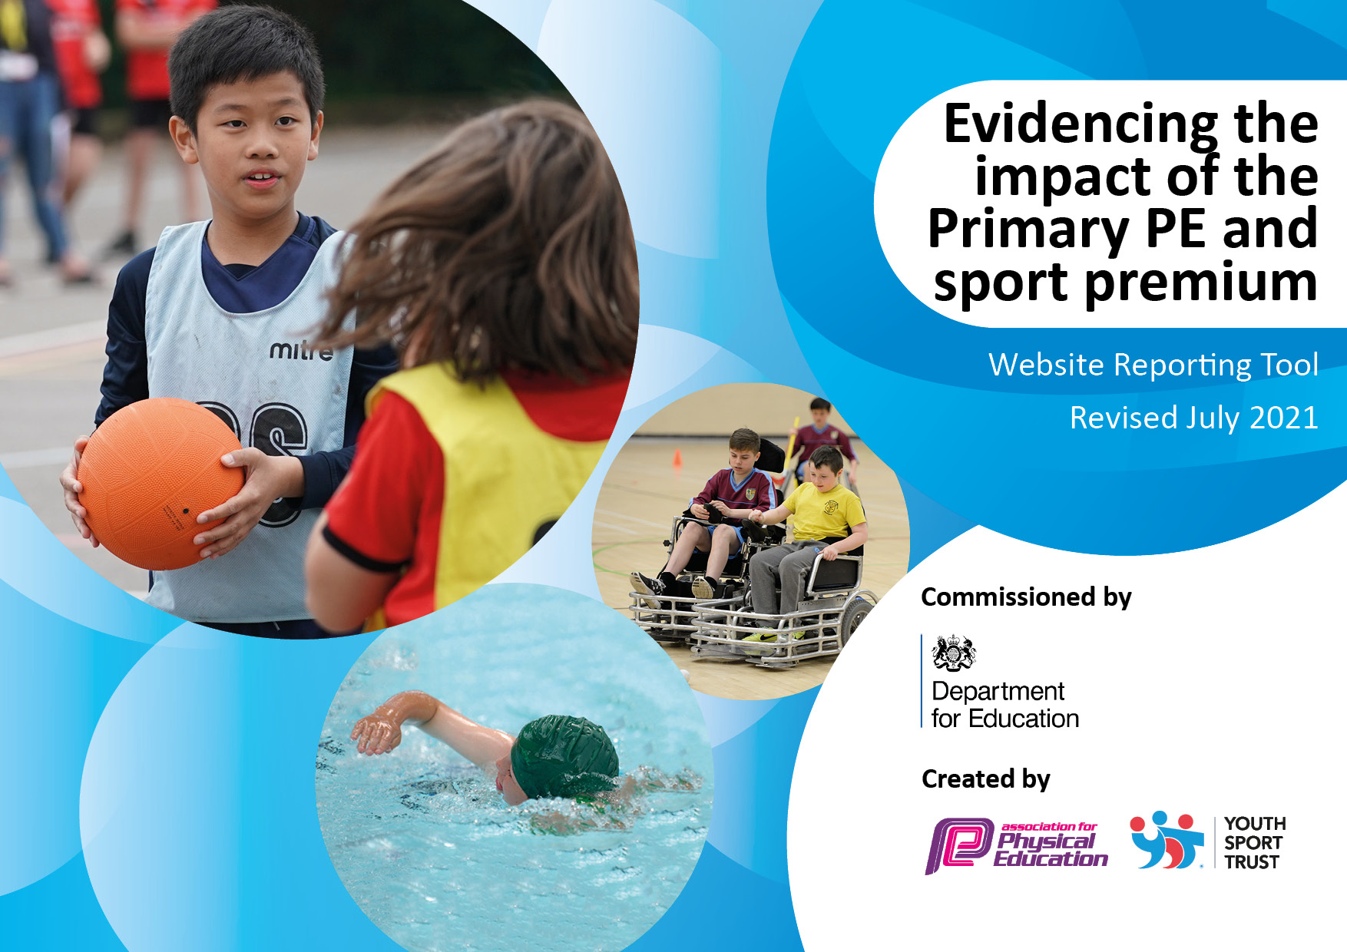
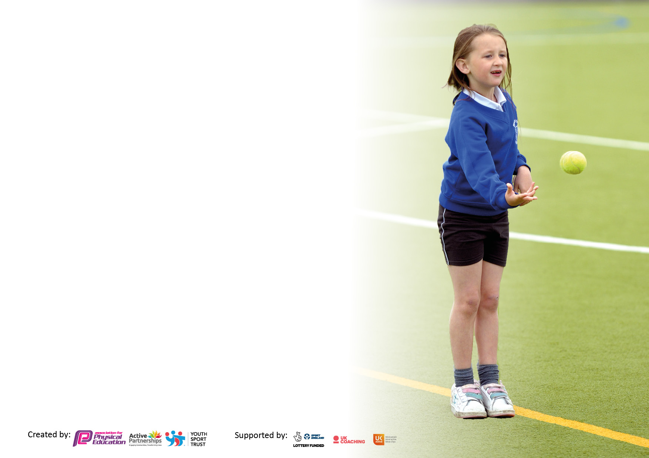

It is important that your grant is used effectively and based on school need. The Education Inspection Framework makes clear there will be a focus on ‘whether leaders and those responsible for governors all understand their respective roles and perform these in a way that enhances the effectiveness of the school’.

Under the Quality of Education Ofsted inspectors consider:
Intent - Curriculum design, coverage and appropriateness
Implementation - Curriculum delivery, Teaching (pedagogy) and Assessment
Impact - Attainment and progress

To assist schools with common transferable language this template has been developed to utilise the same three headings which should make your plans easily transferable between working documents.

Schools must use the funding to make additional and sustainable improvements to the quality of Physical Education, School Sport and Physical Activity (PESSPA) they offer. This means that you should use the Primary PE and sport premium to:

- Develop or add to the PESSPA activities that your school already offer
- Build capacity and capability within the school to ensure that improvements made now will benefit pupils joining the school in future years
- The Primary PE and sport premium should not be used to fund capital spend projects; the school’s budget should fund these.

Pleasevisitgov.ukfortherevisedDfEguidanceincludingthe5keyindicatorsacrosswhichschoolsshoulddemonstrate animprovement.Thisdocumentwillhelpyoutoreviewyourprovisionandtoreportyourspend.DfEencouragesschools to use this template as an effective way of meeting the reporting requirements of the Primary PE and sport premium.

We recommend you start by reflecting on the impact of current provision and reviewing the previous spend.

Schools are required to publish details of how they spend this funding, including any under-spend from 2019/2020, as well as on the impact it has on pupils’ PE and sport participation and attainment. All funding must be spent by 31st July 2022.

We recommend regularly updating the table and publishing it on your website throughout the year. This evidences your ongoing self-evaluation of how you are using the funding to secure maximum, sustainable impact. Final copy must be posted on your website by the end of the academic year and no later than the 31st July 2021. To see an example of how to complete the table please click HERE.
Created by: Supported by:

Details with regard to funding
Please complete the table below.

Total amount carried over from 2020/21 | £2,304.01
Total amount allocated for 2021/22 | £17,770 (20,074.01)
How much (if any) do you intend to carry over from this total fund into 2022/23? | £
Total amount allocated for 2022/23 | £
Total amount of funding for 2022/23. To be spent and reported on by 31st July 2023. | £
Swimming Data
Please report on your Swimming Data below.

Meeting national curriculum requirements for swimming and water safety.

N.B. Complete this section to your best ability. For example you might have practised safe self-rescue techniques on dry land which you can then transfer to the pool when school swimming restarts.
Due to exceptional circumstances priority should be given to ensuring that pupils can perform safe self rescue even if they do not fully meet the first two requirements of the NC programme of study
What percentage of your current Year 6 cohort swim competently, confidently and proficiently over a distance of at least 25 metres?  N.B. Even though your pupils may swim in another year please report on their attainment on leaving primary school at the end of the summer term 2020.  Please see note above | 100%
What percentage of your current Year 6 cohort use a range of strokes effectively [for example, front crawl, backstroke and breaststroke]?  Please see note above | 80%
What percentage of your current Year 6 cohort perform safe self-rescue in different water-based situations? | 100%
Schools can choose to use the Primary PE and sport premium to provide additional provision for swimming but this must be for activity over and above the national curriculum requirements. Have you used it in this way? | Yes

Action Plan and Budget Tracking
Capture your intended annual spend against the 5 key indicators. Clarify the success criteria and evidence of impact that you intend to measure to evaluate for pupils today and for the future.

Academic Year: 2021/22 | Total fund allocated: | Date Updated:
Key indicator 1: The engagement of all pupils in regular physical activity – Chief Medical Officers guidelines recommend that primary school pupils undertake at least 30 minutes of physical activity a day in school |  |  |  | Percentage of total allocation:
 |  |  |  | %
Intent | Implementation |  | Impact
Your school focus should be clear what you want the pupils to know and be able to do and about  what they need to learn and to  consolidate through practice: | Make sure your actions to achieve are linked to your intentions: | Funding allocated: | Evidence of impact: what do pupils now know and what can they now do? What has changed?: | Sustainability and suggested next steps:
Develop more active playtimes and lunchtimes by ensuring all staff training is robust (playground games), equipment is appropriate and accessible. Ensure golden mile is happening at lunchtimes and in class.  Improvement of playground markings to encourage more active playtimes and introduce children to a variety of different activities. Development of sports leaders and playground ambassadors to introduce a variety of games through markings.  Offer booster swimming lessons to children in Yr6 that are not meeting NC expectations and requirements.  Further PE equipment purchased, to include a range of diverse additional sports, including forest schools. | -Develop skill set/ training of MDSA’s to ensure opportunities to promote physical activity are maximised.  -Ensure a rota is applied for Yr 5/6 ‘Huff and Puff’ leaders.  -Increase the health and well being of children across the school.  -Help children who lead sedentary lifestyles to be more active.  -Quote to be obtained through inspired playgrounds. Discussion with HT and Governors. Committed to spend  -Hire more pool time and life guard at lessons.  -Use Yr5 Assessment to establish ‘booster’ children.  -Complete a PE equipment audit and purchase equipment as necessary inline with new long term plan | £100  £8274.00  £615.00  £1265.00  £ Gymnastics | -Children are happy with the new equipment/playground markings and using it during break and lunch times.  -Pupil voice suggests that pupil are feeling fitter and more active.  -Year 6 are taking out and putting away the huff and puff equipment in line with the established rota.  -Children are choosing to run the golden mile during lunchtime in addition to daily class golden mile.  To be implemented Autumn term 2022 – evidence to be completed April 2023. (children using the markings successfully during playtimes and lunch)  All year 6 children are leaving school being able to swim the national curriculum requirements of 25m.  Pupil participation and enjoyment.  Pupil Voice | -Ensure that huff and puff is used and updated as needed.  - Ensure a rota is maintained through the year and into the next year.  -Continue to promote the golden mile and track distances achieved. -Staff and children to take part in a ‘race for life’ school fundraiser event.  To be used across all years with the aim to increase physical activity and co-ordination - Staff and pupils to be trained on how to use the markings effectively.  -Continue to assess children in Yr 3,4 and 5 to monitor who is achieving NC expectations and who is likely to need further booster sessions.  Ensure all staff are aware of the new resources and how to use them.  Base inter-house competitions on the wider range of alternative sports.
Key indicator 2: The profile of PESSPA being raised across the school as a tool for whole school improvement |  |  |  | Percentage of total allocation:
 |  |  |  | %
Intent | Implementation |  | Impact
Your school focus should be clear what you want the pupils to know and be able to do and about  what they need to learn and to  consolidate through practice: | Make sure your actions to achieve are linked to your intentions: | Funding allocated: | Evidence of impact: what do pupils now know and what can they now do? What has changed?: | Sustainability and suggested next steps:
Meeting with HT and staff to update and inform changes to Sport Premium and what we should be doing to raise the profile of PE  -Train Yr5/6 pupils to become sports leaders and run lunchtime clubs. Sports leaders to help run Sports day.  -Achieve the school Games Mark at at least bronze level  Bikeability  Promote sport and healthy lifestyle for home and school based activities.  Employ/use Fortius to provide ‘booster’ PE sessions for children that fall into the category of reluctant/SEND/PP/lower ability/ELSA/low self esteem to raise the profile of sports and healthy lifestyles. | -Time given to prepare notes  - Discuss with HT and staff how teachers should be providing additional activity in class each day. Running the golden mile in addition to lunch times and PE lessons. Show teachers examples of active lessons.  -PE lead to liaise with Yr5/6 children to arrange a rota for all year groups to participate in activities.  -PE lead to dedicate PE lesson time to train the whole class to become playground leaders  -PE lead to be given additional time to spend monitoring children at lunchtime  -PE lead to be given time to ensure that everything is being achieved for the games mark.  -Year 6 children to participate in bikeability activities. Bikeability promoted.  Ensure there is a safe place for all bikes to be kept during the school day.  PE lead to research different schemes sponsored by supermarkets and companies, both local and national.  PE lead to liase with staff and Fortius. Arrange 6 children from each class to benefit from small group work on a Monday afternoon. YR/1/2, Y3/4 and Y5/6 to each get an additional 40 minute PE session/week for the summer term. | £100  £200  £100  £0  £0  Inclusive of Fortius package see page 8. | -PE staff meeting held  -All staff have increased daily activity in their classroom  -Children have actively taken part in sports leader activities.  -School achieved the Gold games mark, children are receiving high quality PE lessons, they are experiencing a wide variety of content in PE and are attending sporting activities outside school  More pupils are able to ride a bike safely and confidently.  Cycling, at home, during lockdown ensured active lifestyle continued.  Children experience a range of sports, improved fitness and interest.  Pupil and staff voice has evidence that children are improving not only in skill but confidence from the additional PE sessions. Staff have noted a significant improvement and pupils have fed back they they have found the sessions fun and beneficial. | - Continue to keep staff updated on any future changes  -Continue to train children next year, developing training through inspired playgrounds  - Continue to give Sports leaders more responsibilities linked to other events – such as sports day.  -Maintain the Gold level Games Mark next year, possibly work towards platinum.  Ensure bikeability is booked again for next year.  Boost the profile of sport and healthy lifestyle/living, especially within the local community.  Continue contract with Fortius next year, continue to provide provision in the summer term for those children that benefit the most. Look into possibly providing provision all year round.

Key indicator 3: Increased confidence, knowledge and skills of all staff in teaching PE and sport |  |  |  | Percentage of total allocation:
 |  |  |  | %
Intent | Implementation |  | Impact
Your school focus should be clear | Make sure your actions to | Funding | Evidence of impact: what do | Sustainability and suggested
what you want the pupils to know | achieve are linked to your | allocated: | pupils now know and what | next steps:
and be able to do and about | intentions: |  | can they now do? What has
what they need to learn and to |  |  | changed?:
consolidate through practice:
Renew membership with PE planning scheme of work and ensure staff are using it appropriately to deliver high quality PE lessons.  Development of progression of skills documents and assessment documents  Staff meeting to further develop understanding amongst staff in principles of PE teachinga nd the importance of PESSPA  PE lead to have extra release time to monitor lessons/ planning/ teaching and assessment.  Membership with Fortius PE to ensure PE lead is competent and up to date with CPD. PE lead attendance on CPD training events.  Staff to receive additional training during PE lessons from Fortius PE in areas that they are feeling less confident  PE lead to become qualified in teaching school curriculum swimming with Swim England. | -Membership is renewed  -PE lead to monitor use of planning and lesson observations.  -PE lead to have discussions with staff members.  -Ensure staff have access to relevant equipment  -Progression of skills document to be produced and shared with staff based on the planning scheme that is used across the school. Progression of skills document will then lead into the production of assessment documents.  -Share recent CPD with staff through power point and short presentation. -Answer staff questions  -PE lead to use time to monitor lessons. -PE lead to go through planning and assessment with staff.  -PE lead to attend training  -PE lead to feedback to staff  -PE lead to liaise with staff and forties PE to ensure most effective training takes place.  -PE lead to undertake 2 day course in Corsham | £165  £0  £200  £1000  £4800.00  Inclusive of Fortius package.  £500 | -PE lessons are of a high quality.  - PE lessons follow planning, but are adapted where necessary.  - Staff are aware of the progression of skills document and are confidently using it to improve quality of teaching and learning, ensuring continuity and progression across the year groups.  -Minutes to the meeting are in staffroom and copy of video clips/power point available to staff at request.  -Pupil voice survey in PE folder - Monitoring and Assessment in folder.  -Updates given to staff in staff meetings following each course attended and as and when needed.  -PE lessons are of a high quality.  -PE lessons follow planning, but are adapted where necessary. Staff feel confident and safe when delivering PE lessons. Behaviour of children is improved and participation of lessons higher.  -PE lead qualified in Autumn term, qualification meant year 6 booster groups could benefit from teaching. All year 6 children are able to swim 25m as per national curriculum requirements. | -Continue to develop a more rigorous system for teacher assessment in PE.  -Ensure staff are adequately assessing children and using documents to progress planning and teaching.  -Keep staff updated on any updates/ changes.  Continue to monitor PE inline with the SDP.  -Continue to update staff as changes occur  -Training to be monitored and continued into the next year, ECT’s to take priority. Questionnaire for training needed to be completed by staff.  -PE lead to continue using the qualification to teach pupils in the future.
Key indicator 4: Broader experience of a range of sports and activities offered to all pupils |  |  |  | Percentage of total allocation:
Intent | Implementation |  | Impact
Your school focus should be clear | Make sure your actions to | Funding | Evidence of impact: what do | Sustainability and suggested
what you want the pupils to know | achieve are linked to your | allocated: | pupils now know and what | next steps:
and be able to do and about | intentions: |  | can they now do? What has
what they need to learn and to |  |  | changed?:
consolidate through practice:
Fencing for year 5 & 6 children, including the qualification of level 1.  -Additional Yr6 Booster swimming lessons  -Offer a wide variety of extra curricular sporting activities including; football, forest school, basket ball, hockey, multi skills, dodgeball and martial arts.  Celebration of British sports in line with the Queens Jubilee | Neil Bromley from British Fencing organisation will come in and provide training to teachers and children  -Hire more pool time and staff to teach/life guard at lessons. -Use Yr5 Assessment to establish ‘booster’ children.  Liase with various organisations to ensure that a wide variety of sporting activities are offered to children.  Organise a ‘garden party’ with 7 traditional British sporting stations, including; boules, golf, archery, croquet, cricket, tennis and badminton. Children to rotate through the stations as a class through the day to give them the opportunity to try a variety of different traditional sports. | £660  As above  £0  £ | Sword fencing builds self confidence, improves self-efficacy and is an ideal sport for those not inclined to team pursuits. It is also something completely different, that many children haven’t heard of let alone experienced. During the course the children were taught how to stand, attack, defend (parry) and how to turn defence into attack. This led to them all passing their nationally recognised British Fencing Level 1 foil award.  All year 6 children are leaving school being able to swim the national curriculum requirements of 25m.  School is providing an additional 30 active minutes or more, to at least 30% of our pupils and attendance is monitored and tracked.  All children actively participated in the day and pupil voice showed that the children enjoyed each session. | Children have received a flyer to attend Swindon Fencing Club or Cricklade Fencing Club for 4 weeks free of charge. We have actively encouraged them to take up this offer and continue the sport outside of school.  -Continue to assess children in Yr 3,4 and 5 to monitor who is achieving NC expectations and who is likely to need further booster sessions.  -Continue to provide high quality clubs after school and if possible offer more clubs.  -Continue to expose children to a variety of different sports through linked events. Include some of the same events in Sport Relief 2023.

Key indicator 5: Increased participation in competitive sport |  |  |  | Percentage of total allocation:
 |  |  |  | %
Intent | Implementation |  | Impact
Your school focus should be clear | Make sure your actions to | Funding | Evidence of impact: what do | Sustainability and suggested
what you want the pupils to know | achieve are linked to your | allocated: | pupils now know and what | next steps:
and be able to do and about | intentions: |  | can they now do? What has
what they need to learn and to |  |  | changed?:
consolidate through practice:
Entry into the football league for a mixed Yr5/6 football team.  Multi school PE events with Fortius  Multi school PE events with cluster  Swimming Gala  Intra sports competitions – Sports day, Rounders, Tunnel ball, Rowing, Games. | -Enter team into SPSFA  -Provide new kit for the team  -Hold trials for team and arrange training and fixture dates.  -Establish a team, train them and practise for competition. -Ensure the team know the rules. - Liaise with AS from fortius to confirm and finalise details.  -Liase with AS from Warneford. Ensure each class is catered for and knows details of the different events.  -Take the top 16 swimmers (8 boys and 8 girls) of year 4/5/6 to the local swimming pool to compete against 2 other local primary schools.  -PE lead to spend time organising events and tracking results. -Order relevant stickers and trophies. | £80.00  £325  £575  £325  £200 | Children have entered the football league and attended tournaments. St Leonard’s came 2nd in the shield final. A new kit was purchased by a parent for the team.  Children have enetered a variety of external sporting events with other schools from around Swindon including a paralympic SEND focused swimming Gala.  Children in every year group have attended non-competitive and competitive events hosted by the local secondary school with other local/cluster primary schools.  Children have participated in a competitive swimming gala, receiving medals and certificates.  Children have participated in a competitive sports day, receiving stickers and certificates. Children have competed in intra house sports, building confidence, resillience and team spirit. | -Look into having a Y5/6 team and a Y2/3/4 football team.  -Enter the primary schools league again.  Continue to liase with fortius and enter external sporting events.  -Continue to liase with Warneford to ensure links are maintained.  -Children to continue with swimming and ensure that participation happens again next year.  -Enter swimming Gala again. - Monitor if same swimmers are attending, any club swimmers? -Keep a register of club swimmers and monitor progress.  -Continue to hold Intra sports events.  -Look to increase events from beyond summer term to all year round.

Signed off by J Warburton
Head Teacher: | Julie Warburton
Date: | 05.07.22
Subject Leader: | Laura Matthews
Date: | 05.07.22
Governor:
Date:

