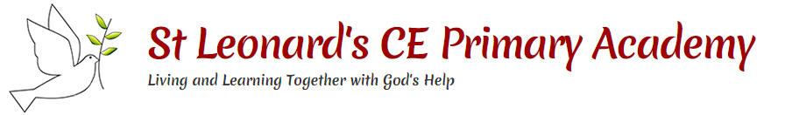

**Key People**

**This topic will link to our resilience and community drivers as we learn about the destruction and rebuilding of London after the Great Fire.**

**Key questions:**

Why is the Great Fire of London a significant event?

What is the timeline of the events of the Great Fire?

How did the fire start and how did it spread?

Why is Samuel Pepys’ diary so important?

How was the fire fought in 1666?

What were the consequences of the fire?

Year 2 Topic: Fire! Fire! The Great Fire of London



|  |  |  |
| --- | --- | --- |
|  | Thomas Farriner | An ember from one of Thomas’ bakery ovens ignited some nearby firewood. The fire quickly spread around the room and to nearby buildings. |
|  | Samuel Pepys | One of the ways we know about the fire is because people wrote about it in their own personal diary. |
|  | King Charles II | Charles was the king of England in 1666. After the fire, he made a decree that houses must be built further apart and built from stone, not wood. |

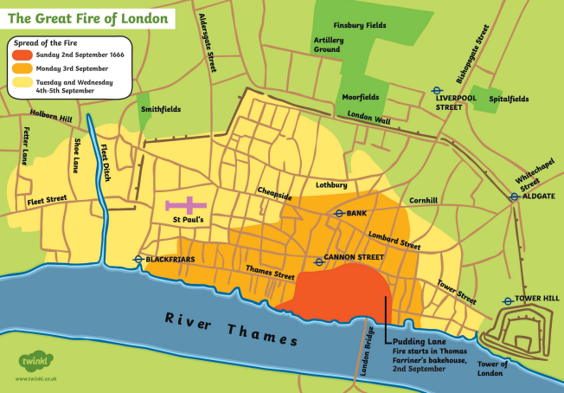

**Vocabulary**

|  |  |
| --- | --- |
| **bakery** | a place where bread or cakes are made or sold |
| **London** | the capital city of England and the United Kingdom |
| **river Thames** | a river running through London |
| **diary** | a personal record of life’s events |
| **eye-witness** | a person who has seen something and can give a description of it |
| **embers** | small pieces of glowing coal or wood in a dying fire |
| **fire-hooks** | giant hooks used to pull down houses |
| **fire-break** | when buildings are destroyed to make a gap to stop a fire spreading |
| **flammable** | when something burns easily |
| **St Paul’s Cathedral** | a Christian building destroyed in the fire and rebuilt using designs by Sir Christopher Wren |

