

**Vocabulary**

|  |  |
| --- | --- |
| **viaduct** | A bridge with a series of arches or columns. |
| **Great Western Railway** | Railway built to link London to Bristol. Among Brunel’s most famous projects. |
| **local area** | Nearby. |
| **national** | Within the same country. |
| **resort** | A popular place for holidays. |
| **tourist** | Someone who travels or visits a place for pleasure. |
| **feature** | An interesting or important part. |
| **physical feature** | A feature that has been formed by nature. |
| **human feature** | A feature that has been made or changed by humans. |
| **pier** | A structure built out into the water for people to walk on. |
| **promenade** | A public place for walking for pleasure. |
| **Victorian** | When Queen Victoria ruled (from 1837-1901). |
| **sea bathing** | Swimming in the sea. |
| **attractions** | Things to see and do. |
| **bay** | Part of the coast where the land curves in and is surrounded by the sea on three sides. |
| **harbour** | A place where ships or boats moor (tie up). |
| **climate** | A pattern of weather. |

**Key questions:**

Who is Isambard Kingdom Brunel and why is he important?

What did Brunel build and what was the impact?

How did Brunel’s railway affect transport links?

How are transport links shown on a map?

What are the geographical features of a seaside?

How does a present-day seaside differ from a past seaside?

**This topic will link to our sustainability and community drivers as we learn about how Brunel has connected our local community to other communities.**

Year 2 Topic: Brilliant Brunel!



* Isambard Kingdom Brunel was an engineer who was born on 9th April 1806 in Portsmouth, England.
* He designed and built many bridges, including the Clifton Suspension Bridge.
* Brunel also designed and built a number of boats. The SS Great Britain was the first wrought iron steamship to cross the Atlantic Ocean and is now moored in Bristol.
* He is perhaps most famous for his work as a chief engineer for the Great Western Railway project.

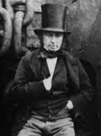

**Human features of the seaside:**

Human features found at the seaside might include the **pier**, the **promenade**, a **lighthouse** and a **fairground**. These features are all man-made.

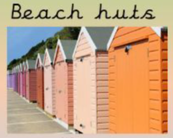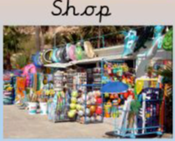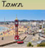

**Physical features of the seaside:**

A seaside resort has many physical features. Features such as the **beach**, the **sea**, **cliffs** and **caves** have been mad naturally. This means they were made by nature.

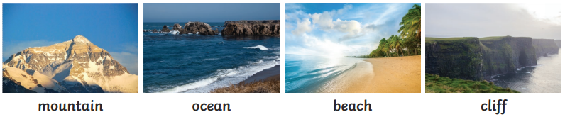

**Visiting Places**

People visits lots of different places. They might visit a local area, travel a bit further and go on a national trip or take a longer holiday somewhere else in the world. Many tourists like to visit the seaside.