

**Key questions:**

What are the differences between living, dead and things that have never been alive?

What are microhabitats?

How do animals obtain their food from plants?

How does our food get from the farm to supermarket?

What are healthy foods?

What is the food chain?

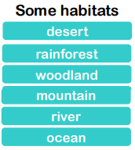

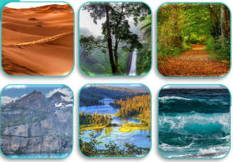

**This topic will link to our respect and sustainability drivers as we learn about environmental issues affecting the world’s wildlife.**

Year 2 Science: Living things and their Habitats



**Vocabulary**

|  |  |
| --- | --- |
| **habitat** | The natural area or place where an animal or plant lives |
| **desert** | An area covered by sand and rocks with very little water or plants |
| **woodland** | A land on which many trees grow which is home to many animals |
| **producer** | A plant is an example of this because it uses the sun to make its own food |
| **root vegetable** | The fleshy root of a plant used as a vegetable such as a carrot, swede or beetroot |
| **living** | Alive |
| **excrete** | To give out cellular waste from the body usually as urine or sweat |
| **microhabitat** | A small home or habitat which is slightly different from some surrounding more extensive habitat |

Did you know?

Thousands of new species of plants and animals are discovered every year.

Many animals and plants have changed over time to adapt to their habitat.

Farmers are busy all year round preparing the ground and growing crops, as well as looking after animals and breeding animals.

A microhabitat is a small area which differs somehow from the surrounding habitat.