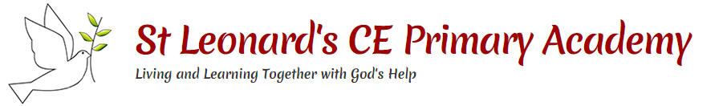

**Deforestation is leaving many living things without homes:**

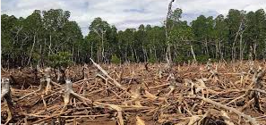

**Microhabitats**

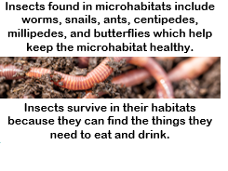

**Key questions:**

Why do living things live where they live?

Why are environments changing?

What is life in the ocean like?

What are the dangers facing ocean life?

What is the Arctic and Antarctic habitat like?

Why is the rainforest in danger?

**This topic will link to our respect and sustainability drivers as we learn about environmental issues affecting the world’s wildlife.**

Year 2 Science: Living things and their Habitats Around the World



**Vocabulary**

|  |  |
| --- | --- |
| **habitat** | A place where living organisms live. |
| **ocean** | A large area of sea. |
| **rainforest** | A forest in a tropical area that receives a lot of rain. |
| **ecosystem** | An area where animals and plants live and where they rely on one another to survive. |
| **extinct** | No longer exists. |
| **endangered** | Animals or plants that may soon not exist because there are very few alive. |
| **climate** | The usual weather conditions of an area. |
| **biodiversity** | A variety of plant and animal life in a particular habitat. |
| **deforestation** | When forests are cut down. |
| **poaching** | Hunting animals to sell. |
| **Arctic** | The northern polar region |
| **Antarctic** | The world’s southernmost continent and the site of the South Pole. |
| **plankton** | Tiny plants and animals which are eaten by other sea creatures. |
| **coral reef** | A ridge of rock in the sea which is home to many sea animals and plants. |
| **pollution** | Waste that is disposed of into the environment. |

Animals living in habitat Food eaten

