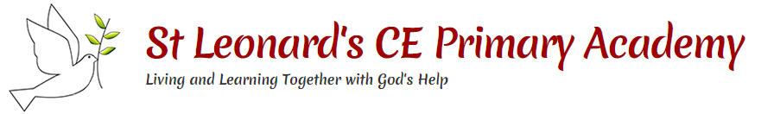

**Key questions:**

Who is significant and why?

How did Florence Nightingale improve nursing?

Who was Mary Seacole and how did she improve nursing?

Who is Edith Cavell and why is she significant?

How are Edith Cavell, Florence Nightingale and Mary Seacole similar? How are they different

Why should we remember them?

**This topic will link to our legacy and community drivers as we learn about the significance of nurses of the past.**

**Key People**

Year 2 Topic: Help is on the Way!



|  |  |
| --- | --- |
|  | Mary Seacole  Mary Seacole was a nurse. Her mother was Jamaican and her father was Scottish. She travelled from Jamaica to look after wounded soldiers on the battlefield in the Crimean War. She set up a hospital called the British Hotel to look after soldiers. |
|  | Edith Cavell  Edith Cavell was a nurse in the First World War. She saved soldiers from both sides during the First World War. Edith helped over 200 soldiers escape from the German Army. |
|  | Florence Nightingale  Florence Nightingale was a nurse. She made hospitals cleaner for patients and looked after soldiers in the Crimean War. She set up the Nightingale Training School for Nurses in 1860. |

**Vocabulary**

|  |  |
| --- | --- |
| **Crimean War** | (1853 – 1856) A war between Russia on one side and Britain, France, the Ottoman Empire (now Turkey) and Sardinia on the other. |
| **battlefield** | A place where soldiers fight in war. |
| **First World War** | (1914-1918). First World War or World War 1. |
| **hospital** | A building where doctors and nurses take care of people who are sick or injured. |
| **nurse** | Somebody who takes care of people who are sick or injured. |
| **patients** | People who are being looked after by nurses and doctors. |
| **soldier** | A person who is trained to fight in wars. |
| **significant** | Great or important, to be worthy of attention |

Did you know?

* Florence Nightingale could speak four languages!
* A statue of Mary Seacole sits at the front of St Thomas’ Hospital in London and is believed to be the first in the UK to honour a black woman.
* When World War One broke out in 1914, Edith Cavell treated soldiers on both sides.

