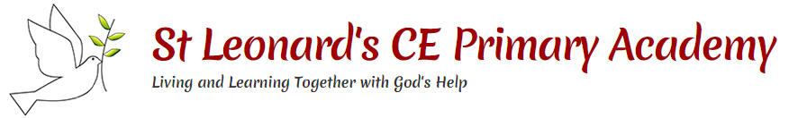

**Frog Life Cycle**

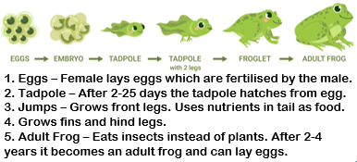

**This topic will link to our community and legacy drivers as we learn about the stages of human life.**

**Key questions:**

What are the stages of the human life cycle?

What happens during the stages of adulthood to old age?

What do children inherit from their parents?

How is the human life cycle different to the life cycle of a chick?

What are the life cycles of a butterfly or a frog?

Year 2 Science: Living things and their Habitats



**Vocabulary**

|  |  |
| --- | --- |
| **life cycle** | A diagram showing the changes in the life of a living thing |
| **foetus** | A baby growing inside its mother’s womb |
| **womb** | Area of the mother’s body where the foetus grows |
| **offspring** | The child, or young, of an animal or plant |
| **reproduction** | The process of producing offspring |
| **transformation** | A change in appearance or form |
| **metamorphosis** | The process of insects, and some animals, developing into adult form through a cycle of change |
| **froglet** | A young frog that has recently changed from being a tadpole |

**Human Life Cycle Ages**

* Foetus – before birth
* Baby – 0-2 years old
* Child – 3-12 years old
* Teenager – 13-17 years old
* Adult – 18-66 years old
* Old age – 67+ years old

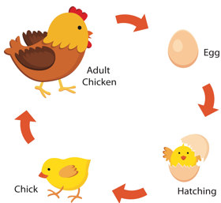

**Human Life Cycle**

