Key questions:
What is the structure of the Earth?
What is the structure of a volcano?
How do earthquakes occur and what are plate tectonics?
Can I use an atlas to find Earth’s major earthquake and Volcano sites?
Why is Pompeii a significant natural disaster?
Can I research natural disasters that have occurred in history?

Geography Year 4 : Volcanoes and Earthquakes
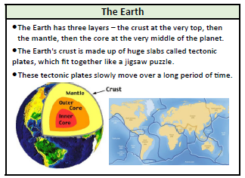
This topic will link to our respect driver as we are learning how devastating some earth movements can be and how we should respect those who are affected by them.

Key Facts
Volcanoes
A volcano is a very deep hole in the earth’s top layer that can let out hot gases, ash and lava. Many volcanoes are also mountains.
Volcanoes have long vents that go all the way down through the earth’s first layer, the crust, to magma in between the crust and the mantle (the earth’s second layer). It’s so hot there that rocks melt into liquid. This is called magma, which travels up through volcanoes and flows out as lava,
There are three ways to describe a volcano and explain what it is doing – active, erupting and dormant.
When a volcano erupts, magma comes up and out through the vents. Magma is called lava when it’s outside the volcano.
Some volcanoes are under water.
There are no volcanoes in the UK. The largest volcano in Europe in Mount Etna in Sicily – part of Italy.
Mountains :
When two tectonic plates of the Earth’s crust grind into each other the land can be pushed upwards, forming mountains.
Many of the greatest mountain ranges of the world have formed because of enormous collisions between the tectonic plates.
When many mountains are close together, this is called a range.
The highest point of a mountain is called the peak or the summit.
Earthquakes
The tectonic plates have edges and sometimes these edges, which are called fault lines, can get stuck but the plates keep moving. Pressure slowly builds up where the edges are stuck and, once the pressure gets strong enough, the plates will suddenly move causing an earthquake.

