Geography Year 4 – North America

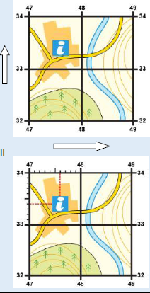
Key questions:
- Finding key areas of North and South America on a map / globe with use of 8 points of a compass and 4 figure grid references
- Understanding OS symbols shown within the UK and the difference in the Americas using digital mapping skills.
- Understanding the topography of North America
- Creating an OS map of an area of North America
- Researching a location of North America for Locational Knowledge
- Present locational knowledge of a chosen area of North America

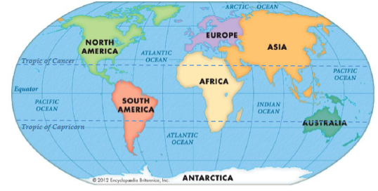
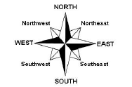
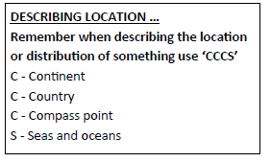
This topic will link to our Resilience and Perseverance driver as we are learning how to read maps and find our way around.

Key Facts
Scale
The scale of a map helps us to calculate the size, height and dimensions of the features shown on the map and the distance between different points. Scale is the ration between real life distances and how many times it has been shrunk to fit on the map.
Grid references
On a map there are grid lines. We use these to pinpoint locations by using a grid reference. Each square on the map has a grid reference. Grid references are easy as long as you remember to go along the corridor before you go up the stairs!
Ordanance Survey Maps
Lots of things on maps are represented by standard symbols. It is a good idea to be able to identify some of these features. They are explained in the key to a map.
Topographic contours
These are lines drawn on maps that join places of the same height. On OS maps they are orange / brown. Sometimes they have their height written on them.
They are always equal distance apart. If the lines are close together then the land is steep, if the lines are far apart then the land is flat or gently sloping.
Vocabulary
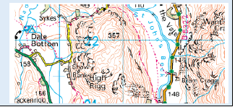
Compass | A device for determining directions by means of a magnetic needle on a pivot and pointing to the magnetic north.
State | A nation or territory considered as an organized political community under one government.
Topography | The study of the shape and features of land surfaces.
America | The Americas the American continent, including North, South, and Central America
Direction | A course along which someone or something moves.

