Key questions:
- When did Ancient Greece take place in history?
- What can we learn about the Greeks based on their buildings and artefacts?
- Can I research gods and goddesses to teach others about
Ancient Greeks religious beliefs?
- What comparisons can be made between Ancient Greek education
and modern day?
- What comparisons can be made between Ancient Greek
governments and modern day?
- Can I show the legacy of Ancient Greece by showing how they are still relevant in present day?
Year 4 Topic: What is the legacy of the Ancient Greeks?
This topic will link to our Legacy driver as we find out how the Ancient Greeks were a real foundation in Western civilisation. Many things from Ancient Greek times still have an effect on our lives today.

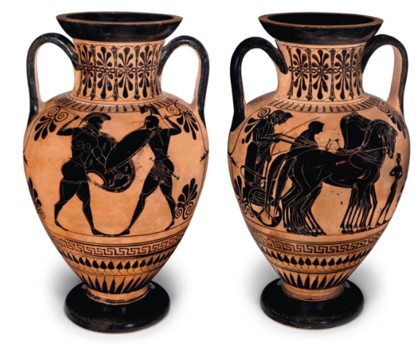
Vocabulary

• Acropolis: an ancient citadel usually on a hill

• Comedy, satire, tragedy: types of theatre plays

• Corinthian, Doric and Ionic: types of architecture

• Democracy: ruled by the people

• Dictatorship: ruled by one person

• Hellenistic: the period of history dominated by Macedonia, of which the most famous ruler was Alexander the Great

• Hoplite: the main type of soldier who fought on foot in Ancient Greece

• Olympic Games: a games event that brings people from different city states together in peace for sports

• Pankration: a vicious sport played in Ancient Greece

• Spartans: tough warriors living in Greek city of Sparta

• Triremes: a Greek warship

• Tyrants: people who seized control of a place and ruled as they wished

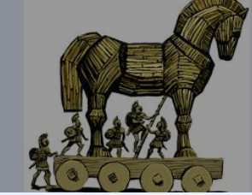
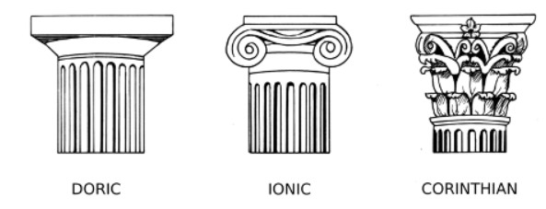

Key Facts and Dates
3000-1400 BC | The Minoan Period – an early part of Ancient Greece
1184 BC | The Trojan War
776BC | The first Olympic Games
490 BC | The Battle of Marathon
8 BC to 800AD | The span of Ancient Greek times
Ancient Greece consisted of many key states – the most important were Athens and Sparta. Athens is often contrasted with Sparta – Athens was more a pioneer of democracy, with Sparta being much
more militaristic. Their democracy was not identical to ours today – for example, women were excluded, as were foreigners and slaves. Many Greeks were fairly poor and some places, including Athens, had large slave societies.

