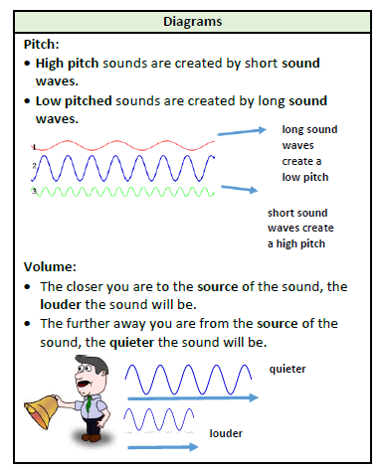
Key questions:
1 – Can I identify how sounds are created and travel to the eardrum.
2- How vibrations from sounds travel through a medium to the ear?
3- How sound insulation works?
4- What is volume?
5-What is pitch?
6- How sounds travel from near and from far?

This topic will link to our Enquiry driver as we are asking lots of questions about sound and conducting several investigations.

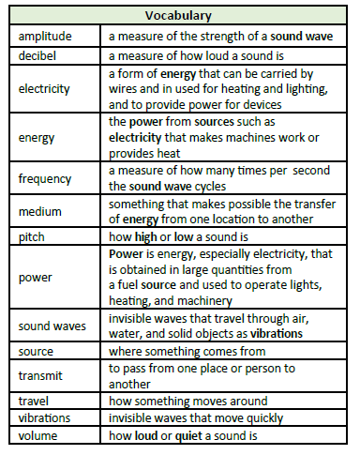

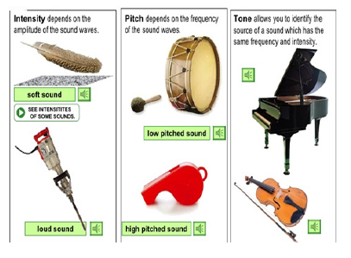

Key Facts
A sound is something that can be heard.
The object that makes the sound is called the source.
When objects vibrate a sound is made. The vibration makes the air around the object vibrate and the air vibrations enter your ear. These are called sound waves. If an object is making sound, a part of it is vibrating, even if you cannot see the vibrations.
Sound waves travel through a medium (such as air, water, glass, stone and brick). For example if somebody is playing music in the room next door, the sound can travel through the bricks in the walls.
When an object vibrates the air around it vibrates too. This vibrating air can also be called sound waves. The sound waves travel to the ear and make the ear drums vibrate. Messages are sent to the brain which recognizes the vibrations as sounds.
Pitch : The pitch of a sound is how high or low it is. A squeak of a mouse has a high pitch and the roar of a lion has a low pitch.
Volume : The volume of a sound is how loud or quiet it is.
When a sound is created by a little amount of energy, a weak sound wave is created which does travel far. This is a quiet sound.
A vibration with lots of energy makes a powerful sound wave and therefore a loud noise.
Amplitude measures how strong a sound wave is. Decibels are the measure of sound. Frequency measures the number of times per second that the sound wave cycles.
What I know:
I can identify, name, draw and label the basic parts of the human body and say which part of the body is associated with each sense. (Year 1 - Animals including Humans)

