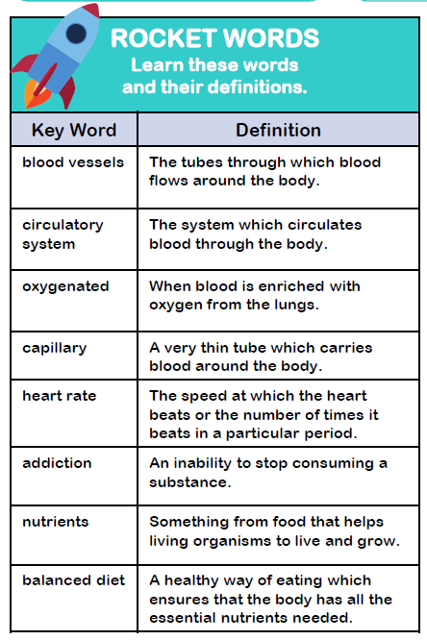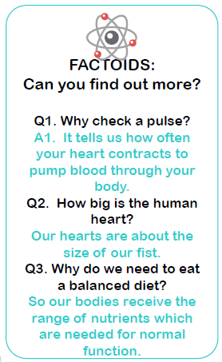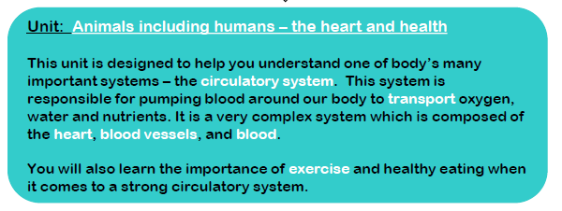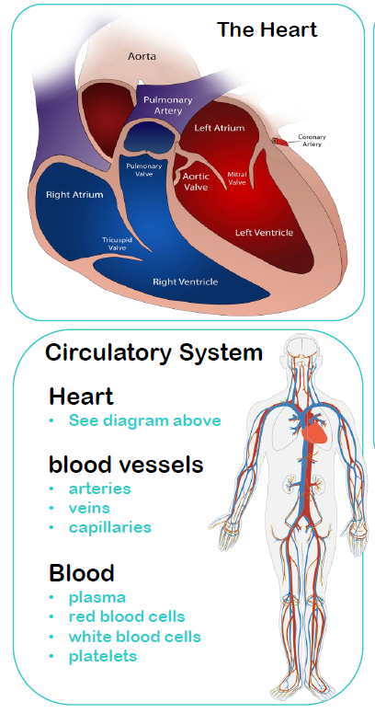Year 6 Topic: The Heart

Enquiry

This topic supports the driver of enquiry through the exploration of how the heart works.

Key Objectives:

1. **Recognise the impact of exercise on the way their bodies function**
2. **Identify and name the main parts of the human circulatory system**
3. **Describe the ways in which nutrients and water are transported within animals, including humans**
4. **Describe the functions of the heart, blood vessels and blood**
5. **Recognise the impact of diet, exercise, drugs and lifestyle on the way their bodies function.**