Key Facts and Dates
Classifying Living Things | Living things are classified into broad groups according to common observable characteristics and based upon similarities and differences, including micro- organisms, plants and animals.
Carl Linnaeus | Carl Linnaeus (Carl von Linne), 1707- 1778, Sweden. Botanist (scientific study of plants), zoologist (study in the classification of animals) and physician (medical professional). Created the binomial nomenclature system to classify living things (plants and animals).
How did Linnaeus classify living  organisms? | A Kingdom is the highest classification into which living organisms are grouped in Linnean taxonomy. The five kingdoms in which living things are grouped are: Protista, Monera, Fungi, Plants, and Animals.
How are classification keys used? | 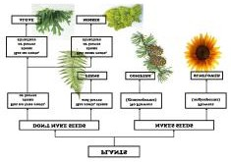  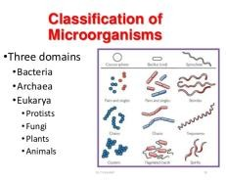  What are the reasons for the groupings? Children work scientifically using classification systems and keys to identify some animals and plants in the immediate environment.

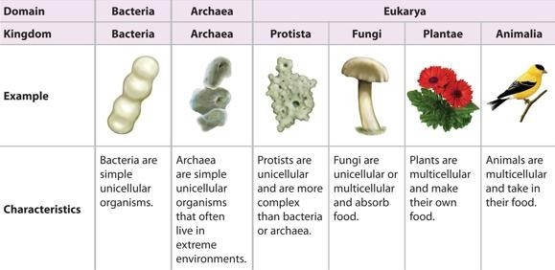
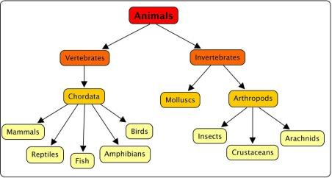
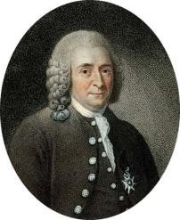
Year 6 Topic: Living Things
Vocabulary
Amphibian – A cold-blooded vertebrate animal that compromises frogs, toads, newts, salamanders and caecilians
Annelid – A segmented worm
Arachnid – An animal that has eight legs and a body formed of two parts Arthropods – An invertebrate with an exoskeleton and a segmented body Bacteria – A single-celled micro-organism that can live anywhere.
Bird – A warm-blooded egg-laying vertebrate animal distinguished by the
possession of feathers, wings, a beak and typically able to fly
Characteristics - a feature or quality belonging typically to a person, place, or thing and serving to identify them.
Classification – the arrangement of animals and plants in groups according to their observed similarities
Crustaceans – Mostly live in water with a hard shell and segmented body Habitat – The natural home or environment of an animal, plant or other organism
Insect – A small animal that has six legs and generally one or two pairs of wings Invertebrate – An animal lacking a backbone
Mammal – A warm-blooded vertebrate animal, distinguishable by the posession of hair or fur, females secreting milk for young and typically giving birth to live young
Microorganism – A microscopic organism, especially a bacteria, virus or fungus Molluscs – An invertebrate with an unsegmented body with a hard shell.
Reptile – A vertebrate animal that has dry scaly skin and typically lay soft- shelled eggs on land
Vertebrate – An animal with possession of a backbone/ spinal column
Key Objectives:
L1) I can describe how living things are classified into groups.
L2) I can identify the characteristics of different types of animals.
L3) I can create a fact file on a new creature showing my knowledge of the different characteristics in each animal group.
L4) I can describe and investigate helpful and harmful microorganisms.
L5) I can conclude my investigation and identify the characteristics of different types of microorganisms.

Tolerance
This topic supports the driver of tolerance. As children develop their knowledge and understanding they will learn how species live together and adapt effectively as environments change.

