What do I need to know?
What is a season? | - There are four seasons:  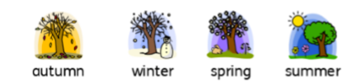  - Autumn - September, October, November  - Winter - December, January, February  - Spring - March, April, May  - Summer - June, July, August
What happens in the autumn? | The temperature beings to fall, which means it gets colder.  The leaves on deciduous trees change colour and begin to fall to the ground.  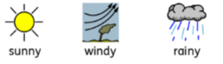  The days get shorter and the nights get longer.  In the autumn, there are events such as Halloween and Bonfire Night.  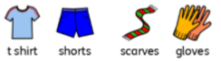  Things people might do are rake leaves, pick blackberries and collect conkers and pine cones.  The weather may be slightly sunny, windy or rainy. There are more clouds in the sky during autumn.  The clothes you might wear include t-shirts and shorts on sunnier and warmer days, and woolly hats and scarves on colder days - especially as it gets closer to winter.
What happens in the winter? | 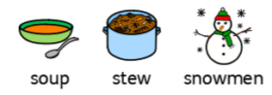  As the seasons change from autumn to winter it gets colder still - this is because the temperature has fallen.  Sometimes, it can freeze overnight and in the mornings, there may be ice and frost.  Deciduous trees have completely lost their leaves and the braches are bare.  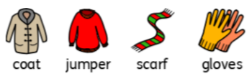  The days get shorter and the nights get longer. Winter has the shortest days and the longest nights of all the seasons.  In the winter, there are events such as Christmas and Valentine’s Day.  Things people might do are build snowmen, eat warm foods like stews and soups and light fires.  The weather may be windy, rainy and chilly. Sometimes it also snows.  The clothes you might wear include warm coats, jumpers, woolly hats and scarves on colder days.
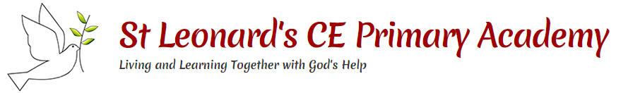
Driver – resilience
As we learn about changes in seasons and track how the weather changes over the seasons.
Vocabulary
Day - length the amount of time where there is daylight.
Daylight - daylight is the natural light that there is during the day, before it gets dark.
Months - one of the twelve amounts of time that a year is divided into.
Nature - the animals, plants, and other things in the world that are not made by people.
Season - the main times of year which can be divided and which have their own typical weather.
Autumn - Autumn is the season between summer and winter when the weather becomes colder and the leaves fall off the trees.
Spring - the season between winter and summer when the weather becomes warmer and plants start to grow again.
Summer - the season between spring and autumn when the weather is usually warm or hot.
Winter - the season between autumn and spring when the weather is usually cold.
Temperature - a measure of how hot or cold something is.
Weather - what the sky and air outside are like, such as cold or sunny.
Snow - soft white bits of frozen water that fall from the sky in cold weather.
Rain - rain is water that falls from the clouds in small drops.
Freeze - when it freezes outside, the temperature falls below 0 degrees.

Year 1 Science: Seasons (Autumn and Winter)

Key questions/activities:
- Go on an autumn nature walk – Can I spot signs of autumn?
- Measure the temperature every day - what do you notice about the difference in temperature from the start of the unit to the end?
- Can I match events to the seasons they happen in? What is weather like during these events (e.g. Christmas Day, Halloween, Bonfire Night?)
- Can I discuss what happens when the children go home from school in the autumn and winter? - what do they notice about daylight? Compare this to what happens in the summer.
- Can I analyse simple graphs that show how day length changes throughout the seasons?
- Can I research animals that hibernate or migrate in winter months?

