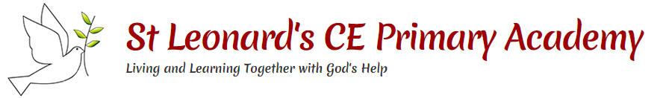
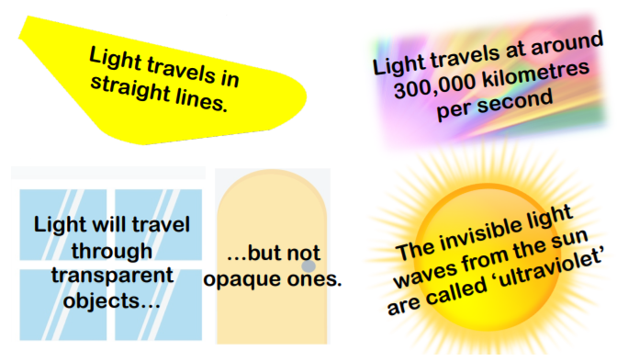
Key questions:
What is a light?
How are shadows formed?
How can we protect ourselves from the sun’s UV rays?
What is the difference between a plan, convex and concave mirror?
How does a periscope work?
How do reflective surfaces keep us safe?
This topic will link to our sustainability driver as we consider light sources and the energy they consume.

Science Year 3 Light
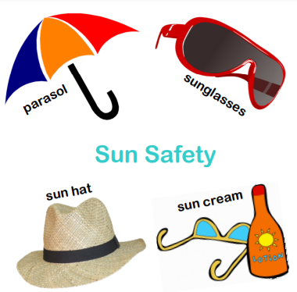

Key Facts
We need light to be able to see things. Light travels in a straight line. When light hits an object, it is reflected (bounces off). If the reflected light hits our eyes, we can see the object. Some surfaces and materials reflect light well. Other materials do not reflect light well. Reflective surfaces and materials can be very useful.
Mirrors reflect light very well, so they create a clear image. An image in a mirror appears to be reversed. For example, if you look in a mirror and raise your right hand, it will appear as though you have raised your left hand.
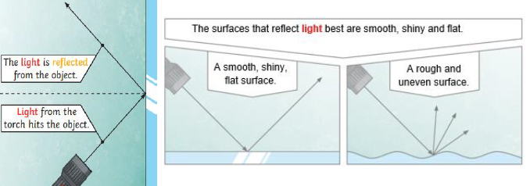
The pupils control the amount of light entering the eyes. If too much light enters, then it can damage the retina. To help protect the eyes, you can wear a hat with a wide brim and sunglasses with a UV rating.
A shadow is caused when light is blocked by an opaque object. A shadow is larger when an object is closer to the light source. This is because it blocks more of the light.
When a light source is to one side of an object, the shadow will appear on the opposite side. | When the light source is directly above the object, the shadow will be directly underneath.

