Key questions:
How does ancient Egypt differ from modern Egypt?
When did ancient Egyptians live?
How much do we know about Egyptian beliefs?
What sort of life did rich Egyptians live?
Who was Tutankhamun?
How can you read ancient Egyptian hieroglyphics?
Vocabulary
BC | Used to show that a date is before the year 0. This is counted backwards, so 200 BC is before 100 BC.
AD | Used to show that a date is after the year 0. This is counted forwards, so AD 100 is before AD 200.
irrigation | A system of canals or channels Egyptians dug to supply water to grow crops over a larger area than the water would reach naturally.
silt | Fine particles of soil, clay or sand carried and left by water.
hieroglyphics | A system of writing that used pictures and symbols (hieroglyphs) instead of letters.
cartouche | An oval shape in which the names of kings and queens were often written in hieroglyphics to show that they were special.
pharaoh | A ruler of ancient Egypt.
afterlife | The place where ancient Egyptians believed they would go after they died.
akhet | The season of the year when the Nile river flooded. A very important time of year in the desert!
canopic jars | Special jars that held the organs of a mummy including the lungs, intestines, liver and stomach.
dynasty | A period of rule when a series of Pharaohs all came from the same family.
mummification | The process of preserving a body after death in preparation for the afterlife
Egyptologist | An archaeologist who focuses on ancient Egypt. Howard Carter was the famous Egyptologist who discovered Tutankhamun’s tomb.
papyrus | A plant that grew on the banks of the Nile. It was used as an early version of paper.
sarcophagus | A large stone box that held a mummy’s coffin. Often richly decorated for Pharaohs.

This topic will link to our Community and Legacy drivers as we find out how the ancient Egyptians lived.

Year 3 Topic: Ancient Egyptians

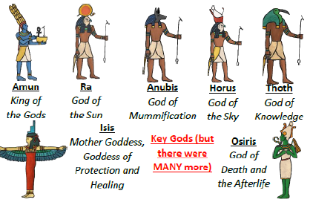
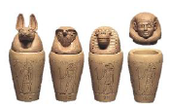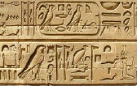
Key Facts and Dates
7500 BC | First settlers in the Nile valley
5000 BC | Farmed wheat, barley and cattle
4500 BC | Use of salts for the first time
3500 BC | First use of hieroglyphics
3000 BC | Building of mud bricks
2500 BC | Sphinx and Giza pyramids
1500 BC | Valley of the kings tombs built
1325 BC | King Tutankhamun buried
332 BC | Alexander the great rules
30 BC | Death of Cleopatra
Did you know?
- Ancient Egyptians were buried with their belongings as they believed that they would need them in the afterlife
- The pyramids at Giza are the only Ancient Wonder of the World that still stands today

