Year 3 Topic: Settlements
Sustainability
This topic will link to our ‘sustainability’ driver, as we find out about how settlements have been developed to help us to survive.
Key questions:
- What is a settlement?
- Why do settlements develop in particular locations?
- When were UK settlements built? Where? Who by?
- How is land used in different settlements?
- Why are transport links so important?
- How are settlements recorded on a map?

Vocabulary
Settlement | A place where people live and sometimes work.
Urban | An area where a large amount of people live near to each other.
Rural | The countryside.
Suburban | The outer parts of a city.
Population Density | The amount of people in a particular area.
Conurbation | A really big, urban area is called a conurbation. This is where the city gets so big that it connects with other nearby towns and cities to form a huge urban area.
Annotation | A note to offer explanation.
Landmark | An object or feature of an area, e.g. school, church.
Scale | The relationship between the distance on a map and the distance on the ground.
Agriculture | Farming and the methods that are used to raise and look after crops and animals.
Forestry | Areas of land covered by forest.
Protected Land | Areas of land reserved for protecting nature.
Coastal | An area of land close to the sea.
Freshwater | Naturally occurring water (e.g. lakes)
Trade | The action of buying and selling goods and services.
Atlas | A book of local or worldwide maps
Industrial | An area of land developed as a site for factories and other industrial businesses
Leisure | A building (or group of buildings) designed to provide facilities for a range of leisure pursuits
Transport links | Connections between different geographical areas by way of transport

Key Facts and Information
What is a Settlement? | Settlements are places where people live and sometimes work. They can be small or large depending on how many people live there and how many facilities there are. Facilities are places where certain things happen, for example, schools for education, parks for playing or shops for selling things.
Settlement Features | When early settlers looked for a site to begin their settlement, they looked for some of the following features to make their lives easier:  - flat land, to make building easier and safer  - local raw materials, e.g. wood and stone, to build homes  - a local water supply for drinking, washing, cooking and transport  - dry land, so that people could build on areas that don’t flood  - a defendable site, e.g. a hilltop or river bend, to protect from attackers  - good farm land with fertile soils, so people could grow crops  - shelter, e.g. to protect from bad weather  - transport links, eg a ford or low crossing point of a river
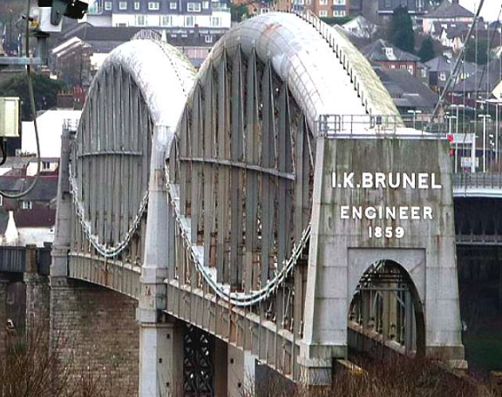
Did you know that one of the newest settlements in the UK is Ebbsfleet? It was recognised in 2014!
Did you know that the oldest settlement in the UK is Amesbury? It was developed around 88820 BC!
Maps of the Blunsdon Village settlement:
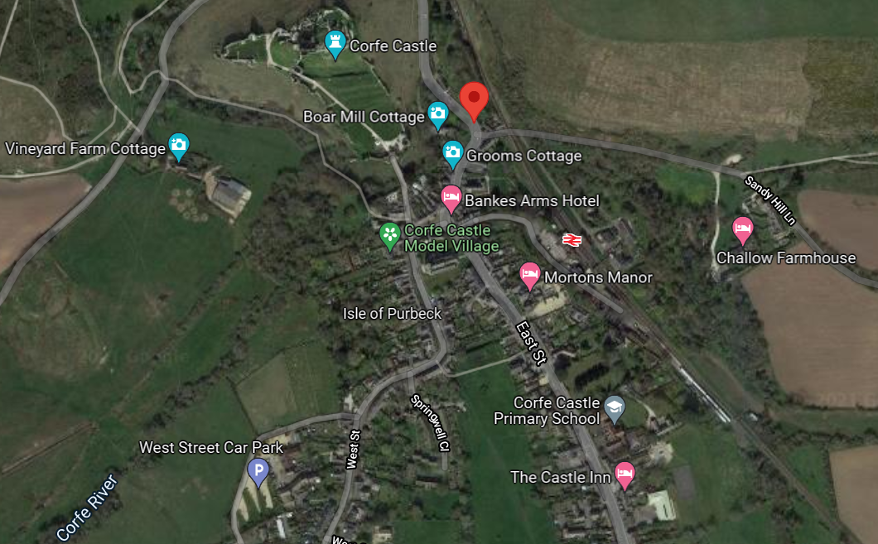
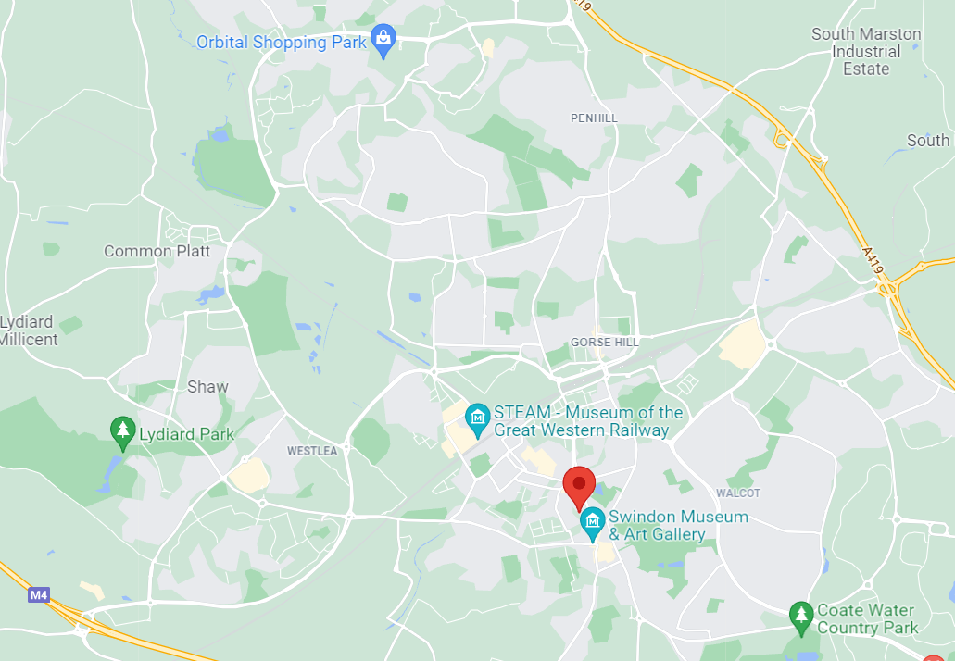

What is important when choosing a new settlement site?
