Year 3 Topic: Stone Age to Iron Age

Key questions:
- How did humans survive in the Stone Age?
- What is Skara Brae and why is it significant?
- What were Stone Age homes like?

This topic will link to our Community, Legacy and Sustainability drivers as we find out how Stone Age humans survived and thrived.

Vocabulary
archaeologist | Someone who studies the past by exploring old remains.
artefact | An object from the past that shows evidence of what life was like.
barrow | A large structure made of earth that people used to build over graves.
bronze | Copper and tin are melted together to make a metal called bronze.
century | a period of 100 years
circa | Latin meaning ‘around’. c. 800 BC = around 800 BC.
druids | powerful religious people
hillfort | settlements built on hills to provide more protection
invasion | to try and take over a place by force
loom | an apparatus that makes fabric using threads
migration | movement from one place to another in order to settle there
rampart | a defensive wall built for protection
remains | traces of the past
resources | something to help when needed
sacrifice | offerings to spirits such as weapons and animals
settler/  settlement | people who migrate to a new place.  When people start a community, this is a settlement.
stone circle | Burials took place in stone circles
trade | the activity of buying, selling and exchanging goods and services

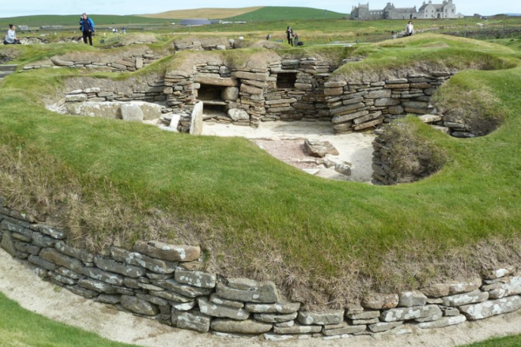
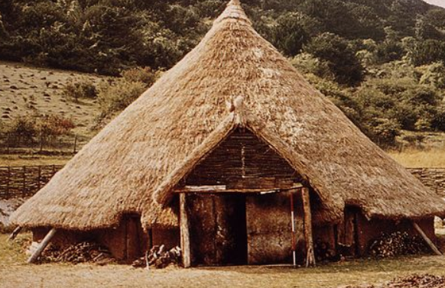
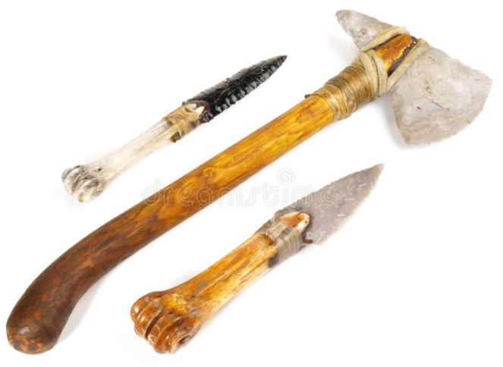

Key Facts and Dates
15,000 BC – 10,000 BC | Cave paintings found in France date back to this time.
4,500 BC – 3,500 BC | People begin to make simple pottery and farming starts to spread.
4,000 BC – 3,000 BC | People begin to ride horses. Before this point, the only way to travel was on foot.
3,000 BC | Construction starts on Stonehenge.
2,500 BC – 1,500 BC | Bronze axes are developed, which leads to advances in woodworking techniques.
1,800 BC | The first large copper mines are dug at this time.
1,000 BC | The cart with wheels is invented.
80 BC | The first coins are thought to have been used.  