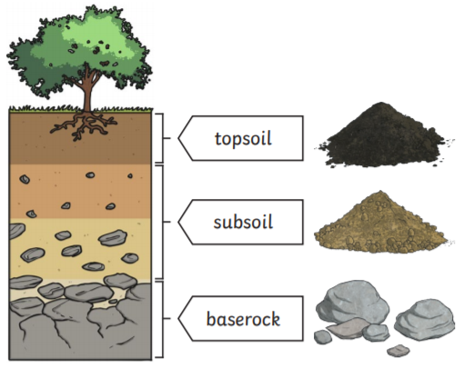
Key questions:
What are the three different types of rock?
What are the different properties of rock?
How is soil formed?
Who is Mary Anning and why were her findings important?
Science Year 3 Rocks and Soils
This topic will link to our resilience driver as we learn about the properties of rocks and soils and what they are able to withstand.

Key Facts
Fossils are formed when an animal dies and is covered with sediments which eventually become rock. More layers of rock cover the sediment and only the hard parts of the creature remain, e.g. bones, shells and teeth. Over thousands of years, sediment can enter the mould to make a cast fossil. Bones can change to mineral but will stay the same shape. When the sea begins to recede, erosion and weathering take place, eventually exposing the fossil.
Soil is the uppermost layer of the Earth. It is a mixture of different things:
Minerals (the minerals in soil come from finely broken-down rock); air; water; organic matter (including living and dead plants and animals)

