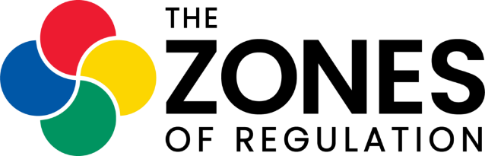
The Zones of Regulation is a curriculum designed to foster self-regulation and emotional control created by Occupational Therapist Leah M. Kuypers.
We use Zones of Regulation across the school. We have found that it has helped us to develop a common language across the school through which to discuss emotions and behaviours.
What is self-regulation?
Self-regulation can be described as the ability to adjust your level of alertness (including your senses, emotions and impulses) to fit the situation you are in and express this through socially appropriate behaviours. For example, the level of alertness required to read a book in a library and that needed to compete in a football match are very different, and the socially expected behaviours in each situation would also differ. It encompasses the skills of self-control, resilience, anger management, impulse control and sensory regulation.
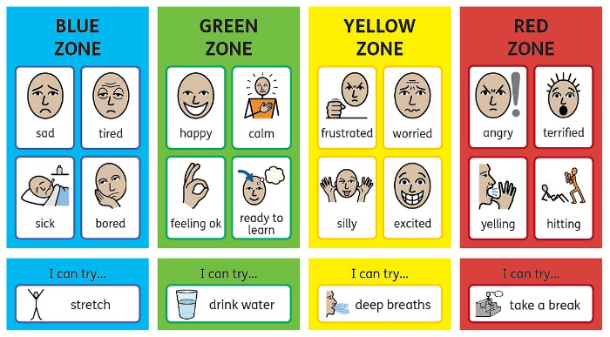
‘The Zones of Regulation' explained
A framework to simplify how we think about and manage our feelings and states
A supportive teaching tool
It categorises complex feelings and states into four coloured ‘Zones’
It improves the ability to recognise and communicate feelings in a safe, non-judgemental way
It helps develop ‘tools’ to move between Zones
It is not:
A discipline model or behaviour approach
Punitive or shaming of negative behaviours
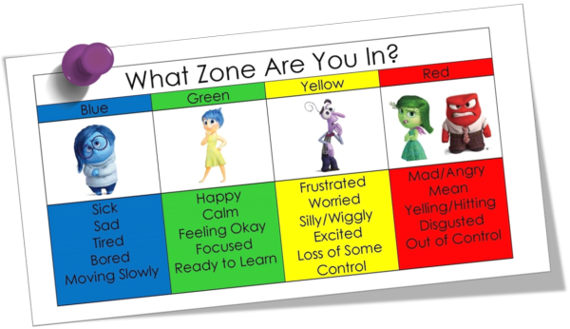

The Zones
The Blue Zone: a low energy state where the ‘slow’ feelings reside, e.g. sad, tired, bored, sick
The Green Zone: the optimum state for the classroom and includes feelings such as: happy, calm, focused, proud
The Yellow Zone: a high energy state where the ‘fizzy’ feelings are found, e.g. excited, frustrated, anxious, silly
The Red Zone: an ‘out of control’ state including feelings such as: angry, aggressive, terrified, elated
There is no ‘bad’ Zone, all Zones are ‘expected’ at different times and in different circumstances
You can be in more than one Zone at a time
Some emotions may fall into more than one Zone
Key Language
Toolbox: a collection of calming and alerting strategies a child can draw upon (can be a literal toolbox or a collection of known strategies)
Tools: calming or alerting strategies that support self-regulation
Trigger: something that causes the child to become less regulated and increases the likelihood of going into the Yellow or Red Zones
Stop, Opt, Go: a concept to aid children in controlling impulses and problem solving better solutions
Expected behaviours: behaviours that give those around you good or comfortable thoughts about you
Unexpected behaviours: behaviours that give people uncomfortable thoughts about you
Inner Critic: negative, self-defeating thoughts
Inner Coach: positive, helpful thoughts

